Age:

Where do they live?

What do they do during Halloween?

What do they do for fun?

Special ability:

© 2021 Little Owls Resources

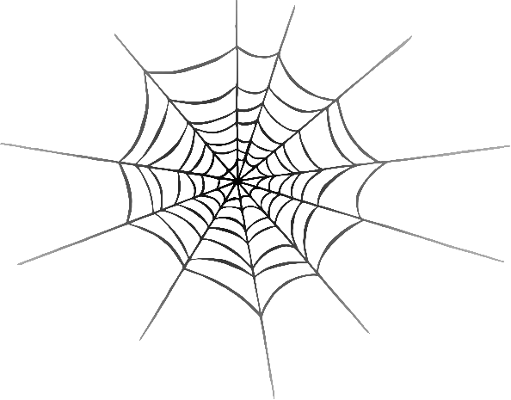

Name:

**Halloween Character Sheet**

Age:

Where do they live?

What do they do during Halloween?

What do they do for fun?

Special ability:

© 2021 Little Owls Resources



Name:

**Halloween Character Sheet**

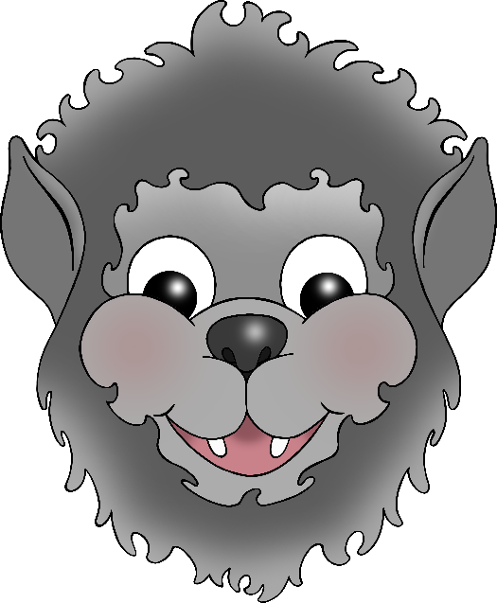

Age:

Where do they live?

What do they do during Halloween?

What do they do for fun?

Special ability:

© 2021 Little Owls Resources



Name:

**Halloween Character Sheet**

Age:

Where do they live?

What do they do during Halloween?

What do they do for fun?

Special ability:

© 2021 Little Owls Resources



Name:

**Halloween Character Sheet**

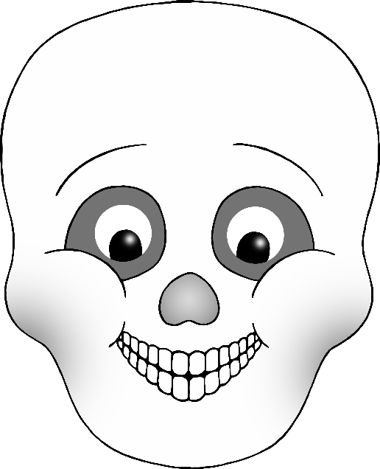

Age:

Where do they live?

What do they do during Halloween?

What do they do for fun?

Special ability:

© 2021 Little Owls Resources



Name:

**Halloween Character Sheet**

Age:

Where do they live?

What do they do during Halloween?

What do they do for fun?

Special ability:

© 2021 Little Owls Resources



Name:

**Halloween Character Sheet**

Age:

Where do they live?

What do they do during Halloween?

What do they do for fun?

Special ability:

© 2021 Little Owls Resources



Name:

**Halloween Character Sheet**