Character name:

What do they do for fun?

© 2021 Little Owls Resources

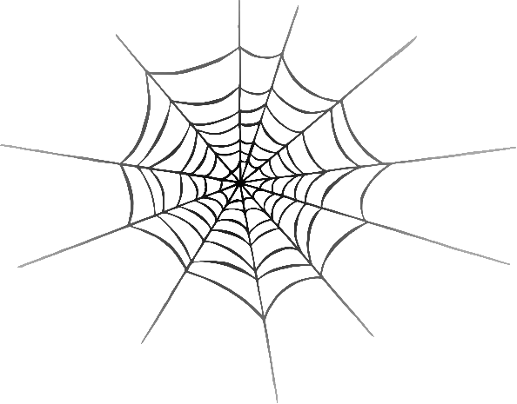

**Halloween Character Sheet**

Character name:

What do they do for fun?

© 2021 Little Owls Resources



**Halloween Character Sheet**

Character name:

What do they do for fun?

© 2021 Little Owls Resources



**Halloween Character Sheet**

Character name:

What do they do for fun?

© 2021 Little Owls Resources



**Halloween Character Sheet**

Character name:

What do they do for fun?

© 2021 Little Owls Resources



**Halloween Character Sheet**

Character name:

What do they do for fun?

© 2021 Little Owls Resources



**Halloween Character Sheet**

Character name:

What do they do for fun?

© 2021 Little Owls Resources



**Halloween Character Sheet**