**skeleton**

© 2021 Little Owls Resources

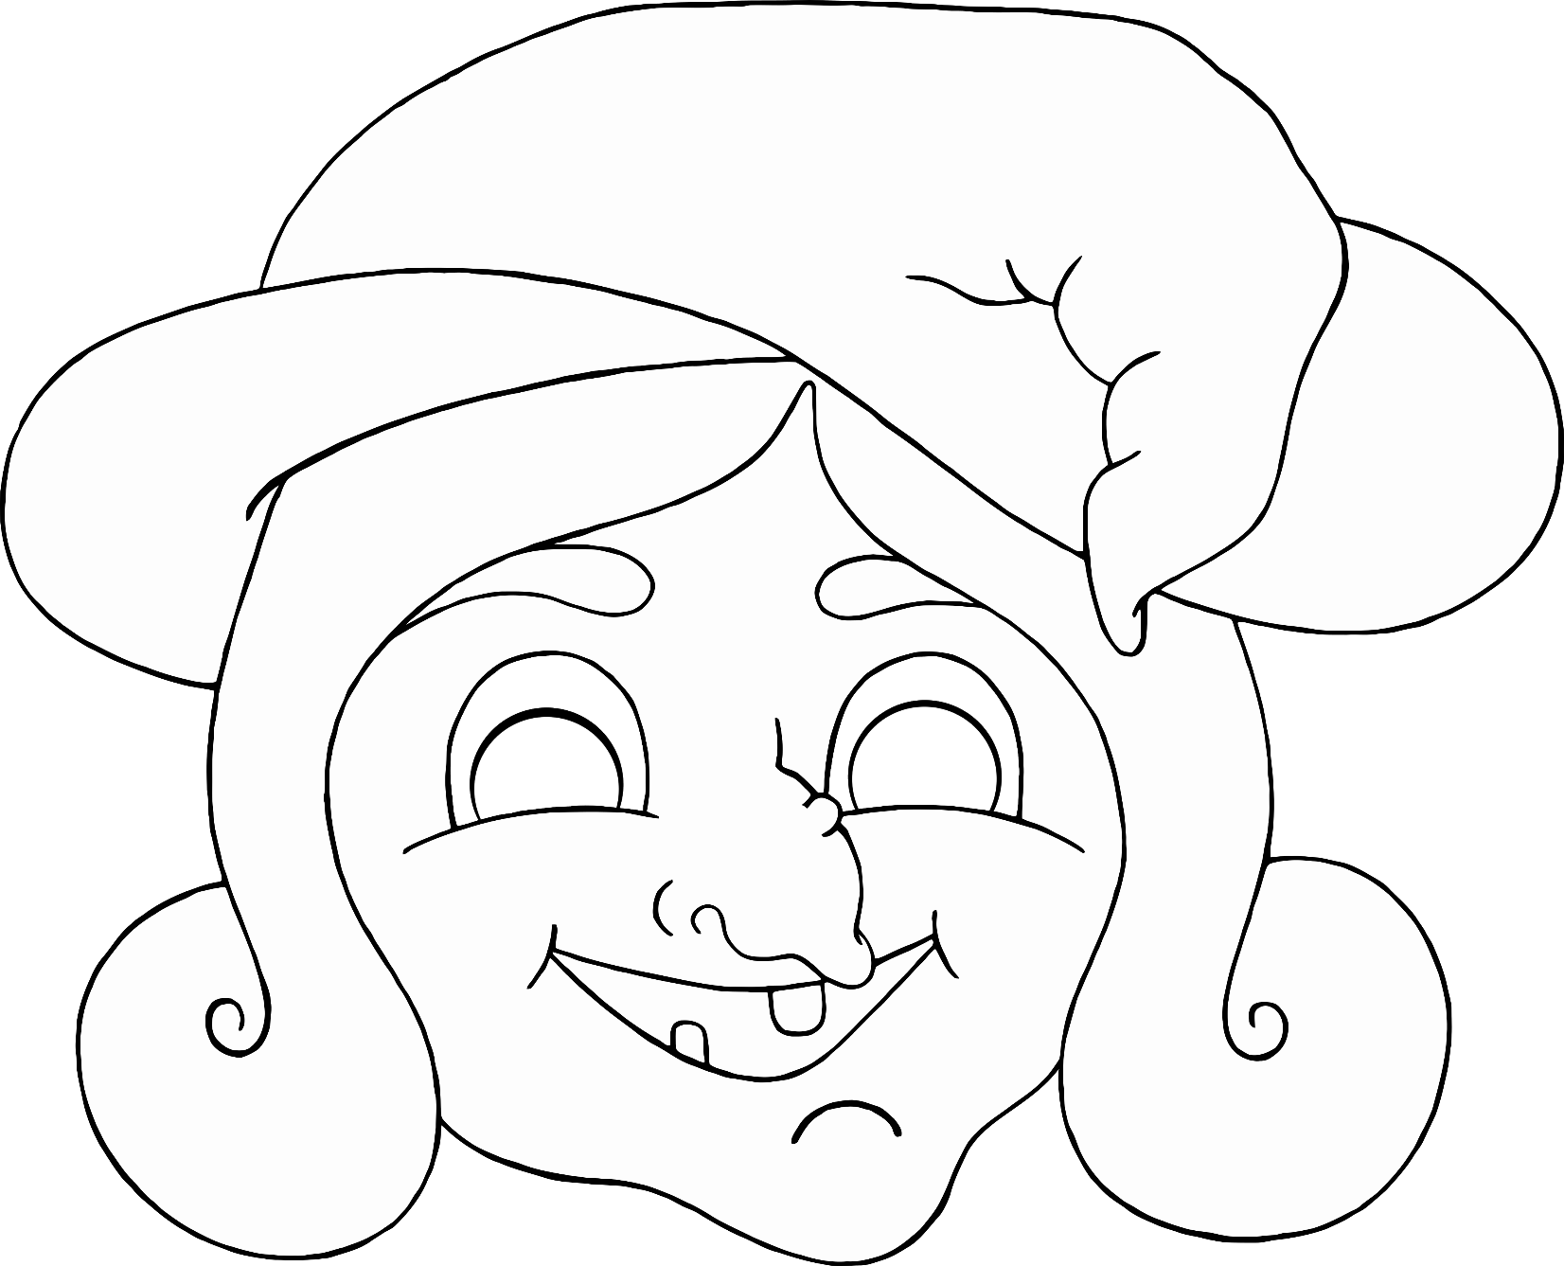

**witch**

© 2021 Little Owls Resources

**wizard**

© 2021 Little Owls Resources

**pumpkin**

© 2021 Little Owls Resources

**werewolf**

© 2021 Little Owls Resources

**mummy**

© 2021 Little Owls Resources