**Halloween Challenge Cards**

These challenge cards are intended to be part of a ‘Halloween’ topic. The cards cover challenges involving number, colour, drawing and more!

© 2021 Little Owls Resources

© 2021 Little Owls Resources

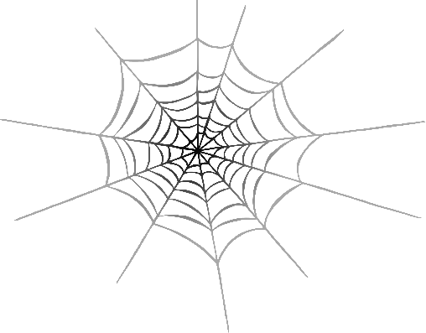

Go!

It’s time to decorate for Halloween…

Find 3 **orange** things.

**Halloween Mission**

**1**

© 2021 Little Owls Resources



Go!

Draw your favourite Halloween food!

**Halloween Mission**

**2**

© 2021 Little Owls Resources



Go!

Find 2 things that would fit inside a pumpkin!

**Halloween Mission**

**3**

© 2021 Little Owls Resources



Go!

Countdown from 10 and then shout

“Boo!”

.

**Halloween Mission**

**4**

© 2021 Little Owls Resources



Go!

Give 3 people 2 sweets each.

How much is that altogether?

**Halloween Mission**

**5**

© 2021 Little Owls Resources



Go!

Find something as small as spider!

**Halloween Mission**

**6**

© 2021 Little Owls Resources



Go!

Draw a picture of someone in a Halloween costume.

**Halloween Mission**

**7**

© 2021 Little Owls Resources



Go!

Count to 10 and then make a ghost sound

“Woooooo!”

**Halloween Mission**

**9**

© 2021 Little Owls Resources



Go!

We need more decorations!

Find 5 **green** things.

**Halloween Mission**

**8**

© 2021 Little Owls Resources



Go!

Draw a funny face pumpkin!

**Halloween Mission**

**10**

© 2021 Little Owls Resources



Go!

Tell a friend your favourite part about Halloween!

**Halloween Mission**

**11**

© 2021 Little Owls Resources



Go!

**Halloween Mission**

**12**

Find 7 **black** things.