**Halloween**

**Activity**

**Challenge!**

**1**

Fly fast on a broomstick…

Wooooosh!

**2**

**2**

Sit down and flick your fingers above you like a bubbling cauldron!

Pop! Fizz! Pop!

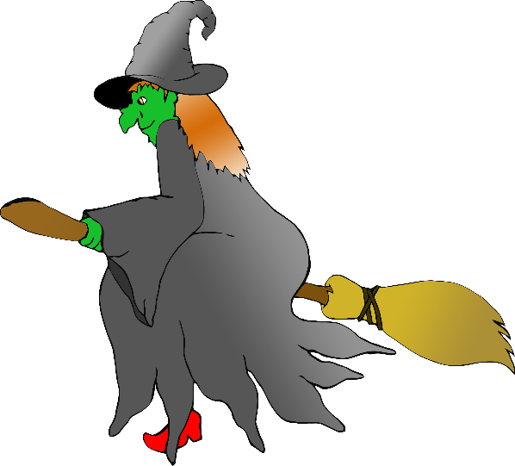

**Halloween**

**Activity**

**Challenge!**

© 2019 Little Owls Resources

© 2019 Little Owls Resources

**3**

**3**

Swoop around like a floating ghost!

**Oooooo!**

**4**

Scuttle around like a giant spider!

Scuttle! Scuttle!

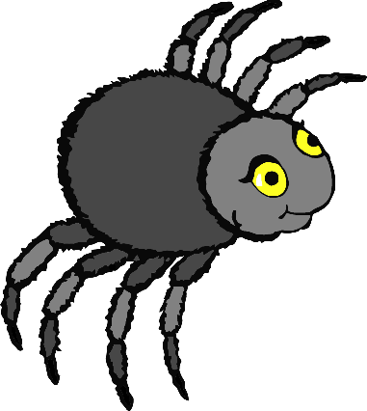

**Halloween**

**Activity**

**Challenge!**

**Halloween**

**Activity**

**Challenge!**

© 2019 Little Owls Resources

© 2019 Little Owls Resources

**5**

Move slowly like a careful cat… then arch your back!

Hissssss!

**6**

Walk a wobbly walk like a skeleton!

Wobble-walk! Wobble-walk!

© 2019 Little Owls Resources

© 2019 Little Owls Resources

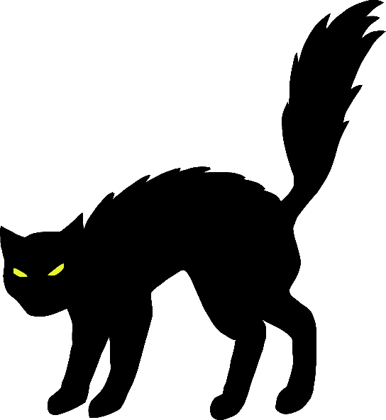

**Halloween**

**Activity**

**Challenge!**

**Halloween**

**Activity**

**Challenge!**

**7**

Crawl around staying as small as you can!

Crawl! Crawl!

**8**

Flap your arms fast like a flying bat!

Flap! Flap! Flap!

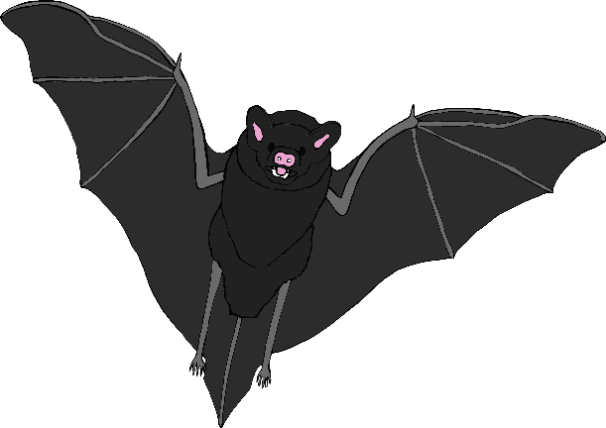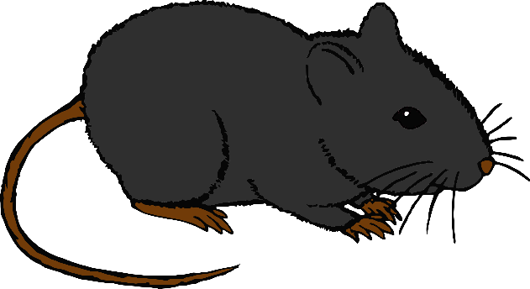

© 2019 Little Owls Resources

© 2019 Little Owls Resources

**Halloween**

**Activity**

**Challenge!**

**Halloween**

**Activity**

**Challenge!**