**wizard**

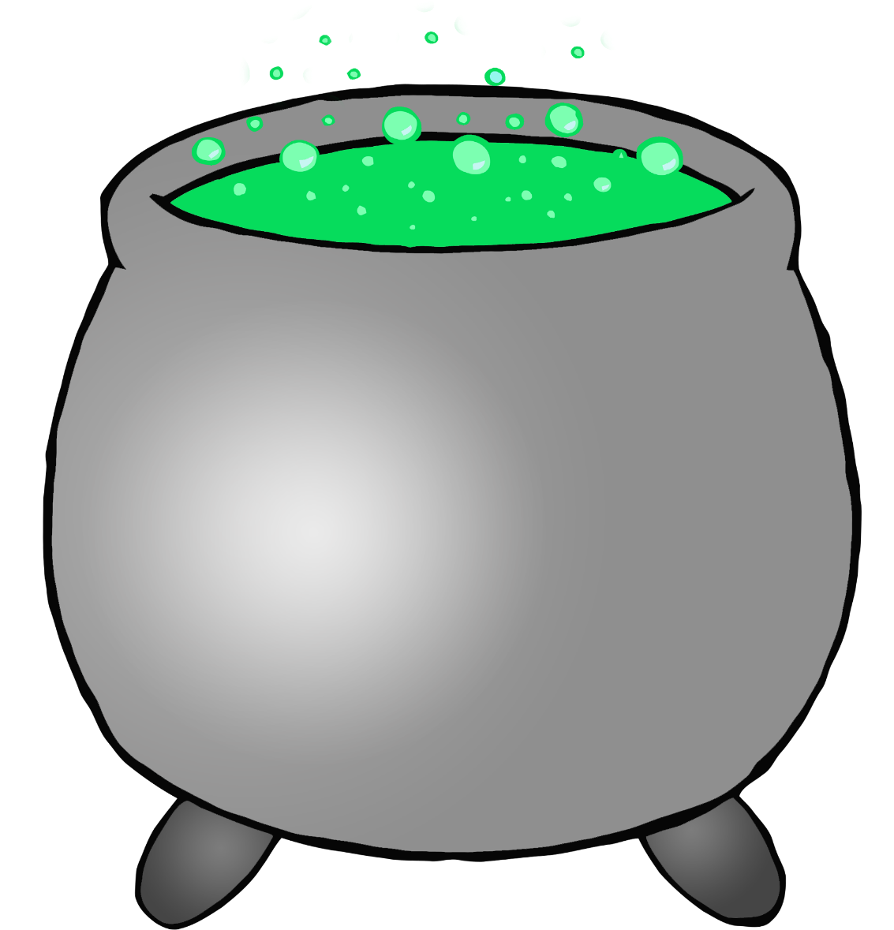

© 2022 Little Owls Resources

**witch**

© 2022 Little Owls Resources

**ghost**

© 2022 Little Owls Resources

**witch hat**

© 2022 Little Owls Resources

**skeleton**

© 2022 Little Owls Resources

**pumpkin**

© 2022 Little Owls Resources