© 2023 Little Owls Resources

Guitar

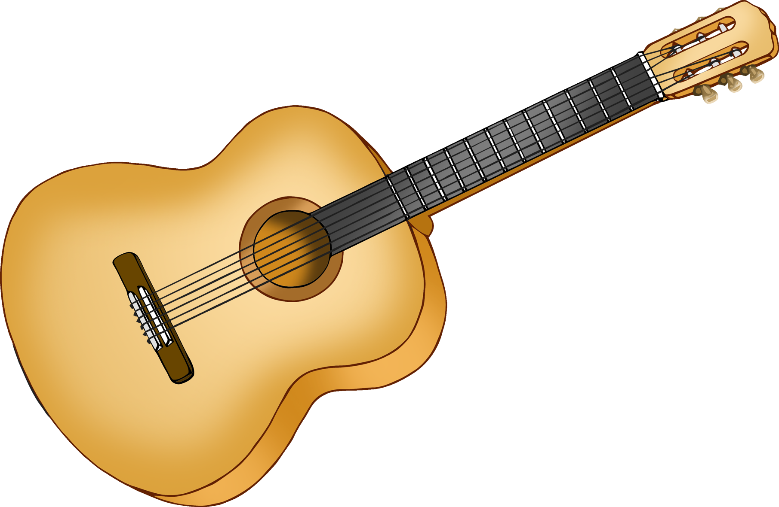

neck

tuning pegs

strings

sound hole

bridge

© 2023 Little Owls Resources

Guitar

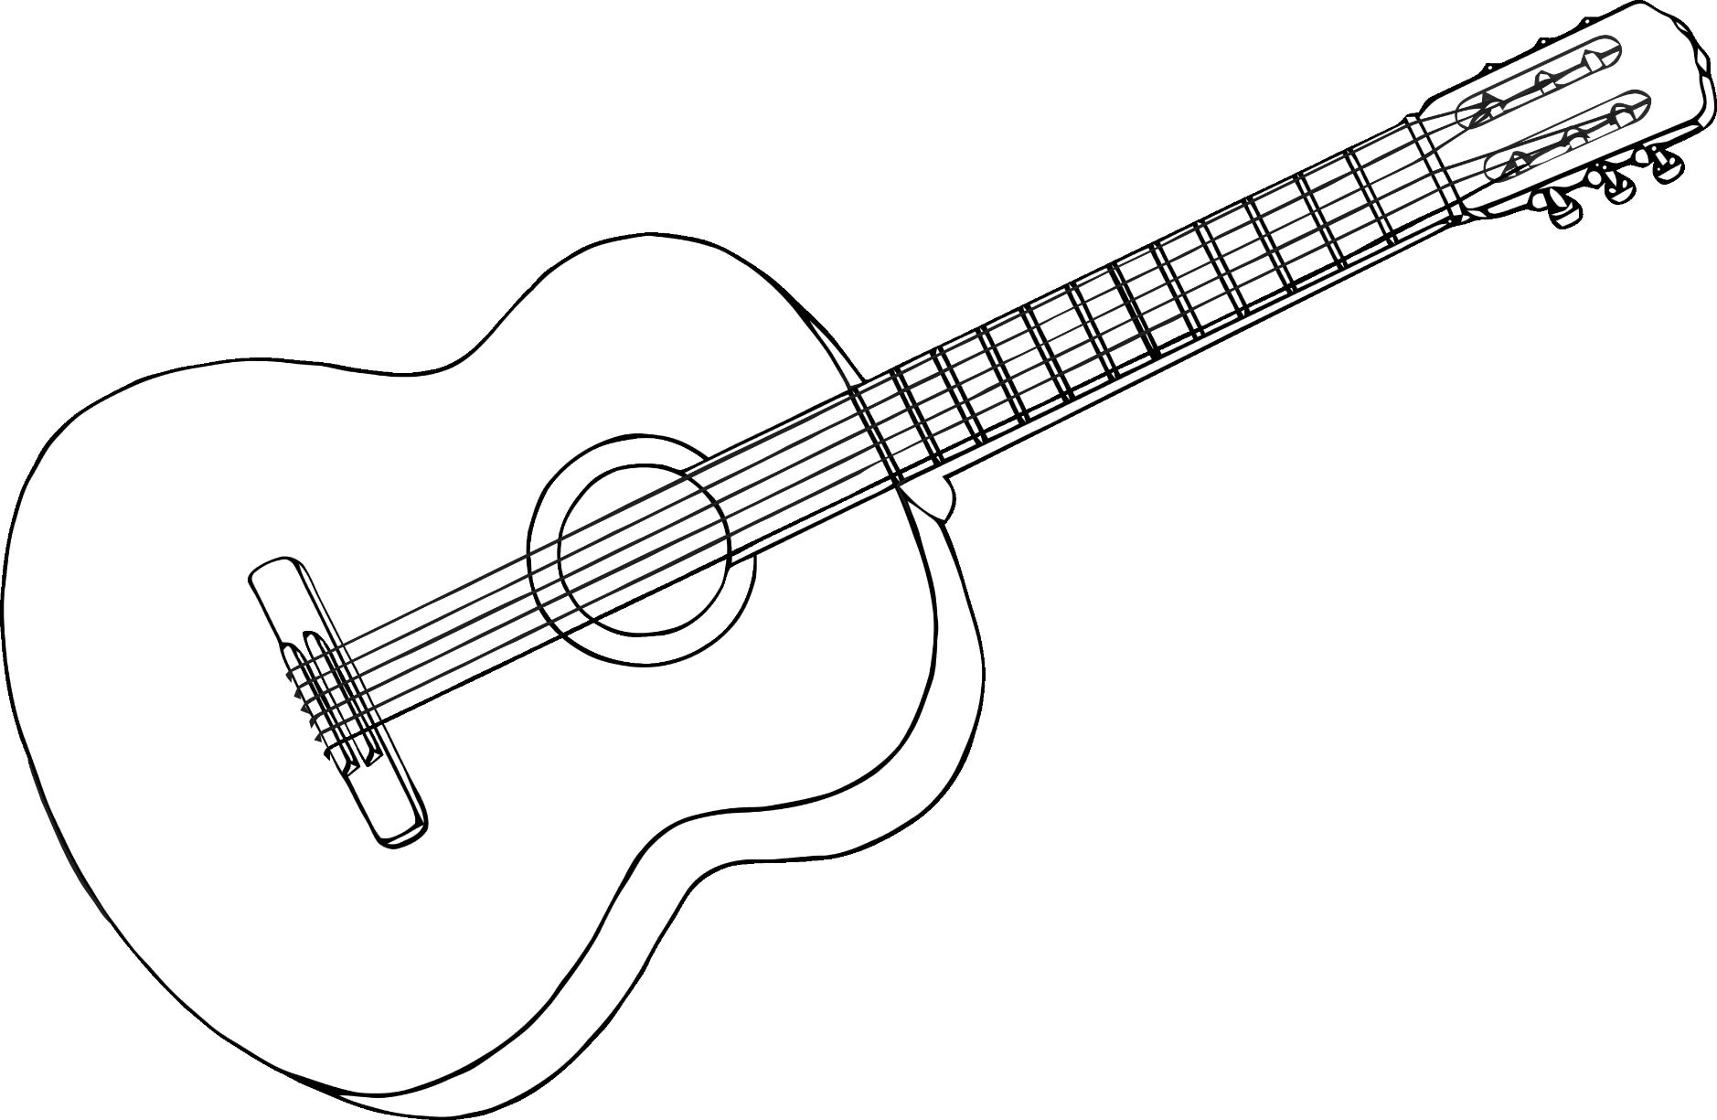

neck

tuning pegs

strings

sound hole

bridge

© 2023 Little Owls Resources

Guitar

