We love challenge!

**Growth Mindset**

© 2022 Little Owls Resources

We learn from our mistakes!

**Growth Mindset**

© 2022 Little Owls Resources

We keep trying!

**Growth Mindset**

© 2022 Little Owls Resources

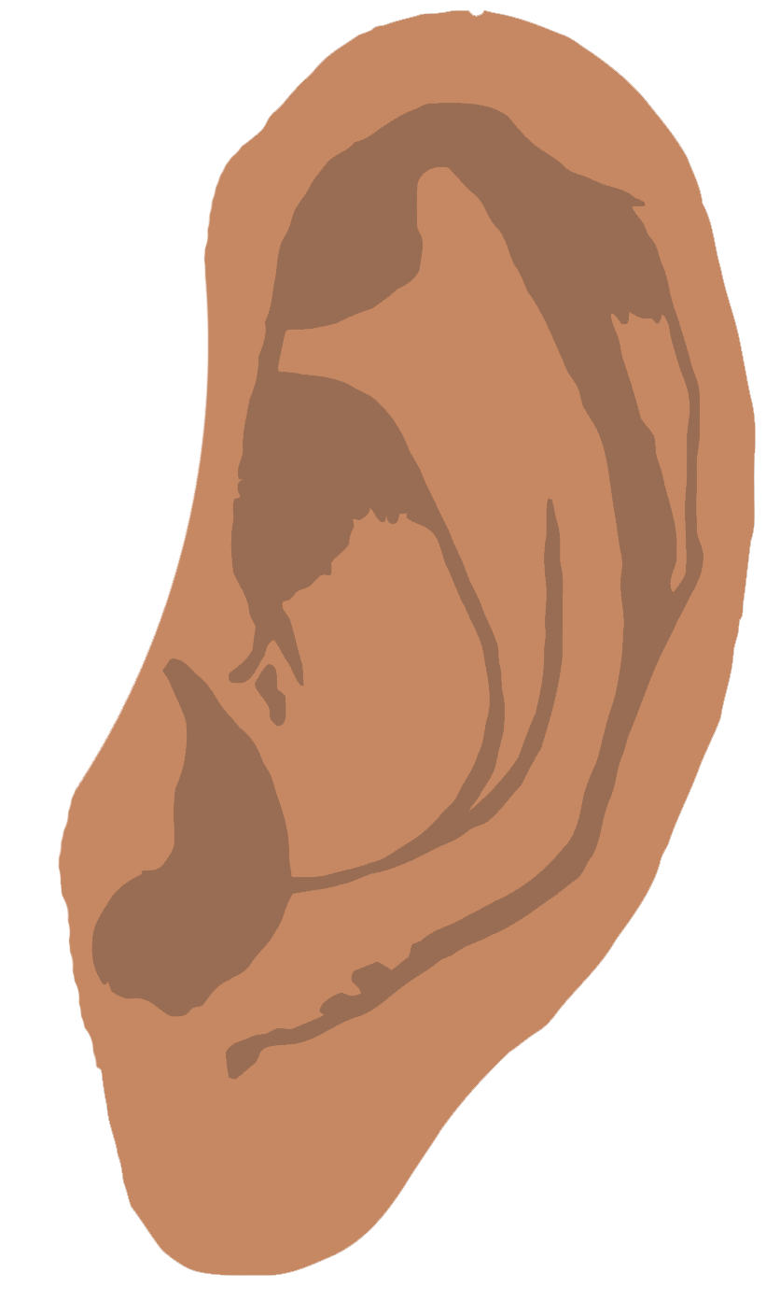

We listen to advice!

**Growth Mindset**

© 2022 Little Owls Resources

Well done!

Amazing!

We love seeing our friends do well!

**Growth Mindset**

© 2022 Little Owls Resources