**Gorilla**

The pages of this pack give some general information about gorillas and some fun and engaging activities to foster and develop children’s interest in them.

**This pack includes:**

* Fact posters x3 (Could be used as stimuli for a lesson input)
* Number slice activity (1-10) (Can be pre-cut for a pure number ordering activity or left to be cut by child to add scissor practice)
* Number slice activity - colouring version (1-10) (As above but to be coloured before cutting)
* Description sheet (Can be used as an independent writing activity or with an adult scribing the ideas of a younger child)
* A4 poster
* A4 poster - colouring version
* ‘Body Parts’ x3 (fully labelled, initial sounds only, blank)
* Draw and write sheets x3 (blank sheet, wide lines and narrow lines)
* 1x 4-piece puzzle
* Multimats x3 (for Colouring/Art & Craft/Loose Parts/Playdough)

© 2021 Little Owls Resources

This pack includes:

The pages of this pack give some general information about the role of a paramedic and some fun and engaging activities to foster and develop children’s interest in this role in society.

© 2021 Little Owls Resources

**Gorilla Facts**

**biggest**

Wild gorillas live for

years.

**35**

Gorillas eat **plants and fruit**.

Gorillas are the apes in the world!

Humans have destroyed lots of places that gorillas used to live.

Humans have hunted and killed many gorillas.

This means there is a very high risk that they may become extinct.

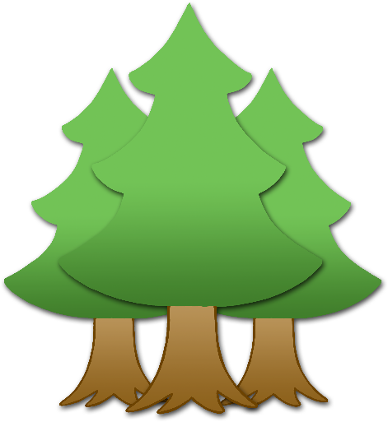

**Gorillas are** Endangered.

© 2021 Little Owls Resources

**How big is a Gorilla?**



130cm / 1.3m

© 2021 Little Owls Resources

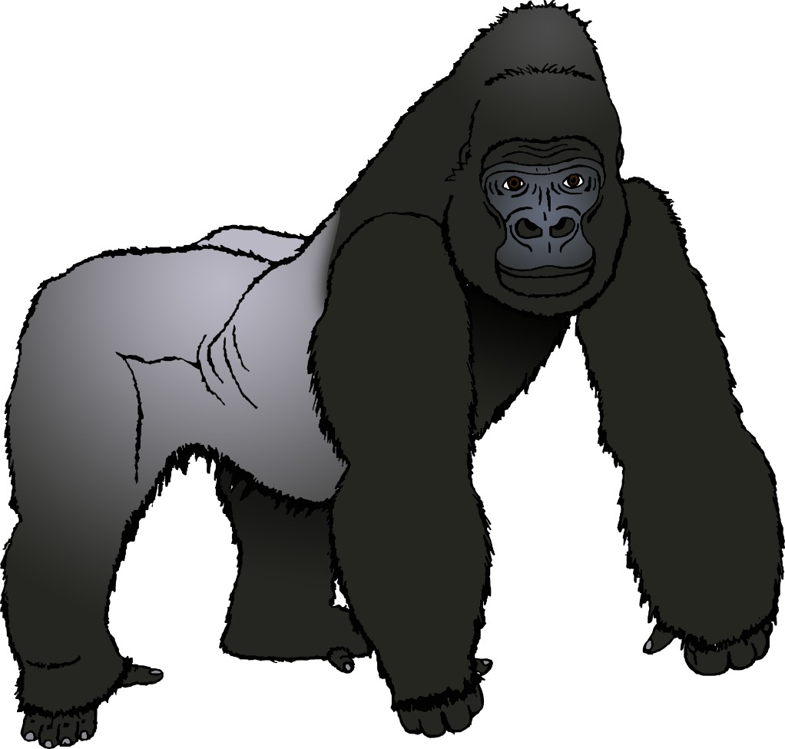

1

2

3

4

5

6

7

8

9

10

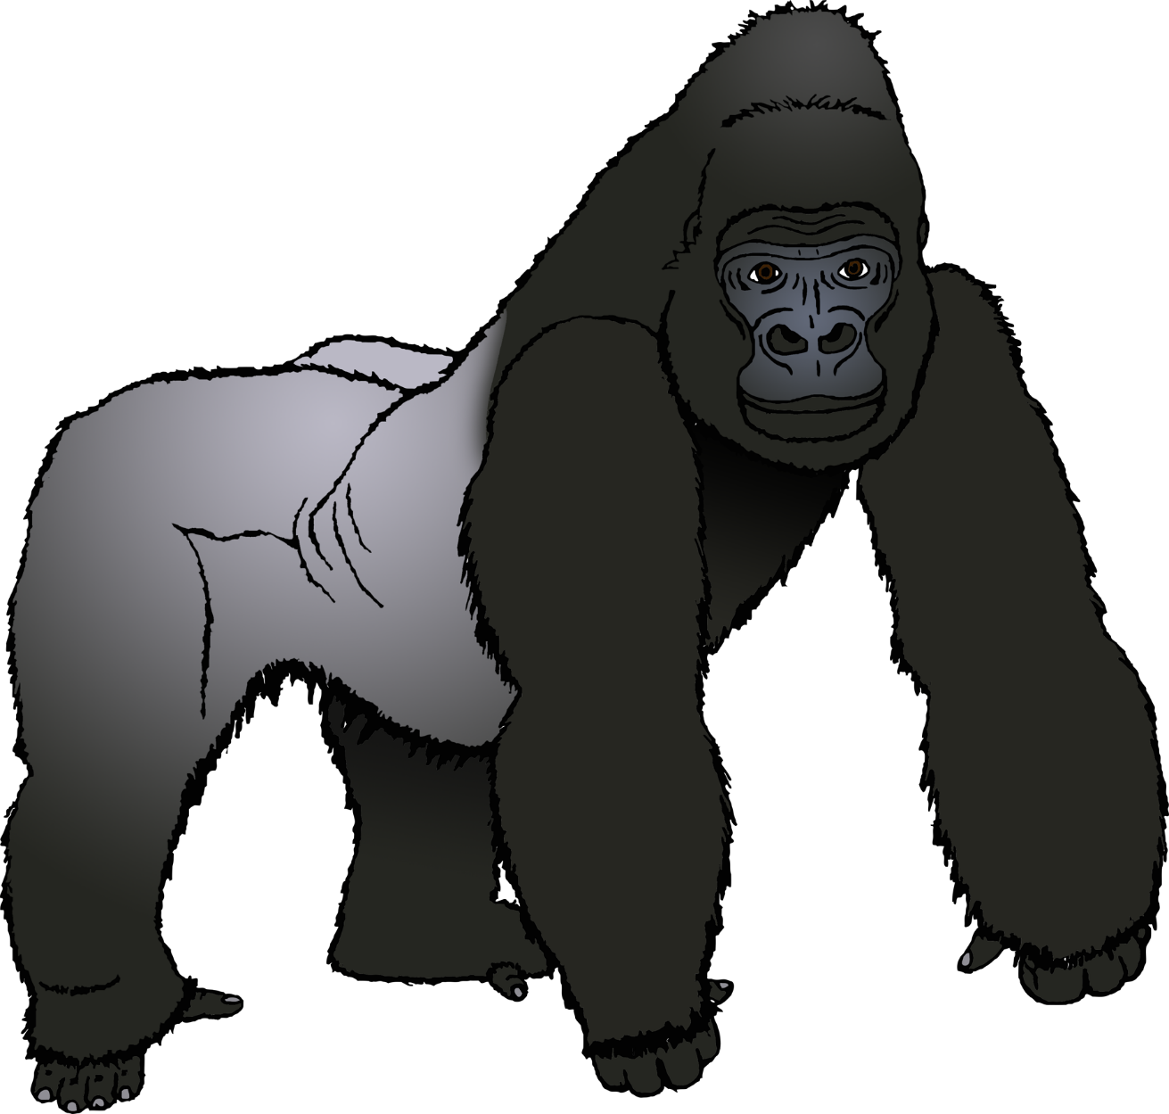

© 2021 Little Owls Resources

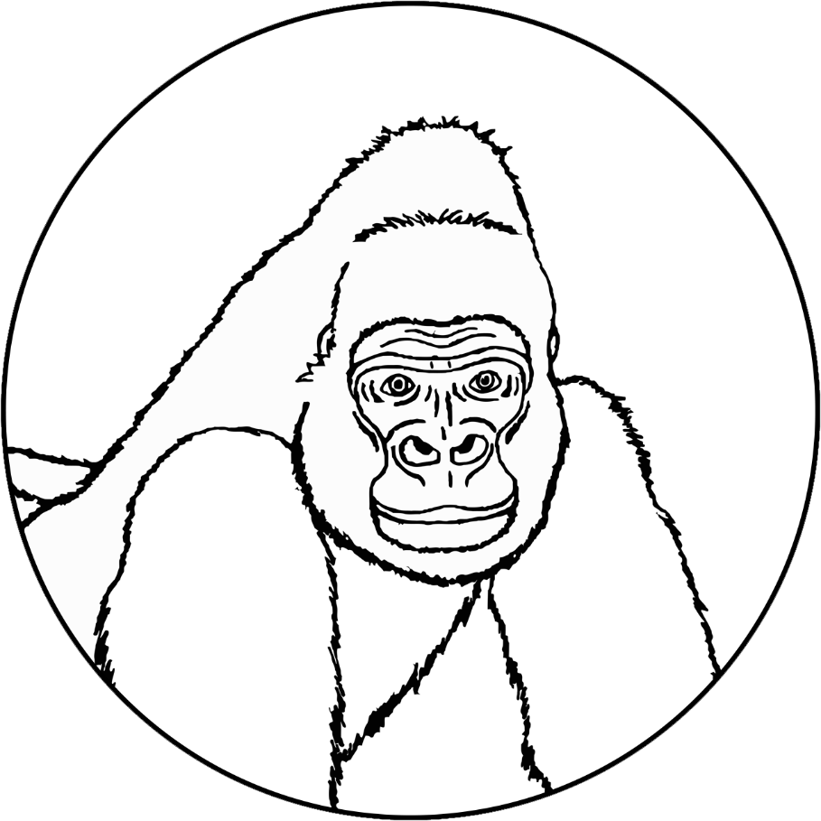

© 2021 Little Owls Resources

1

2

3

4

5

6

7

8

9

10

© 2021 Little Owls Resources

**What words would you use to describe a gorilla?**

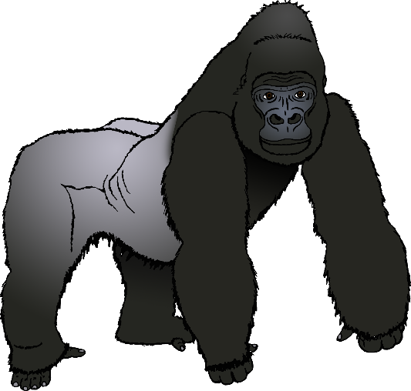

**Gorilla**

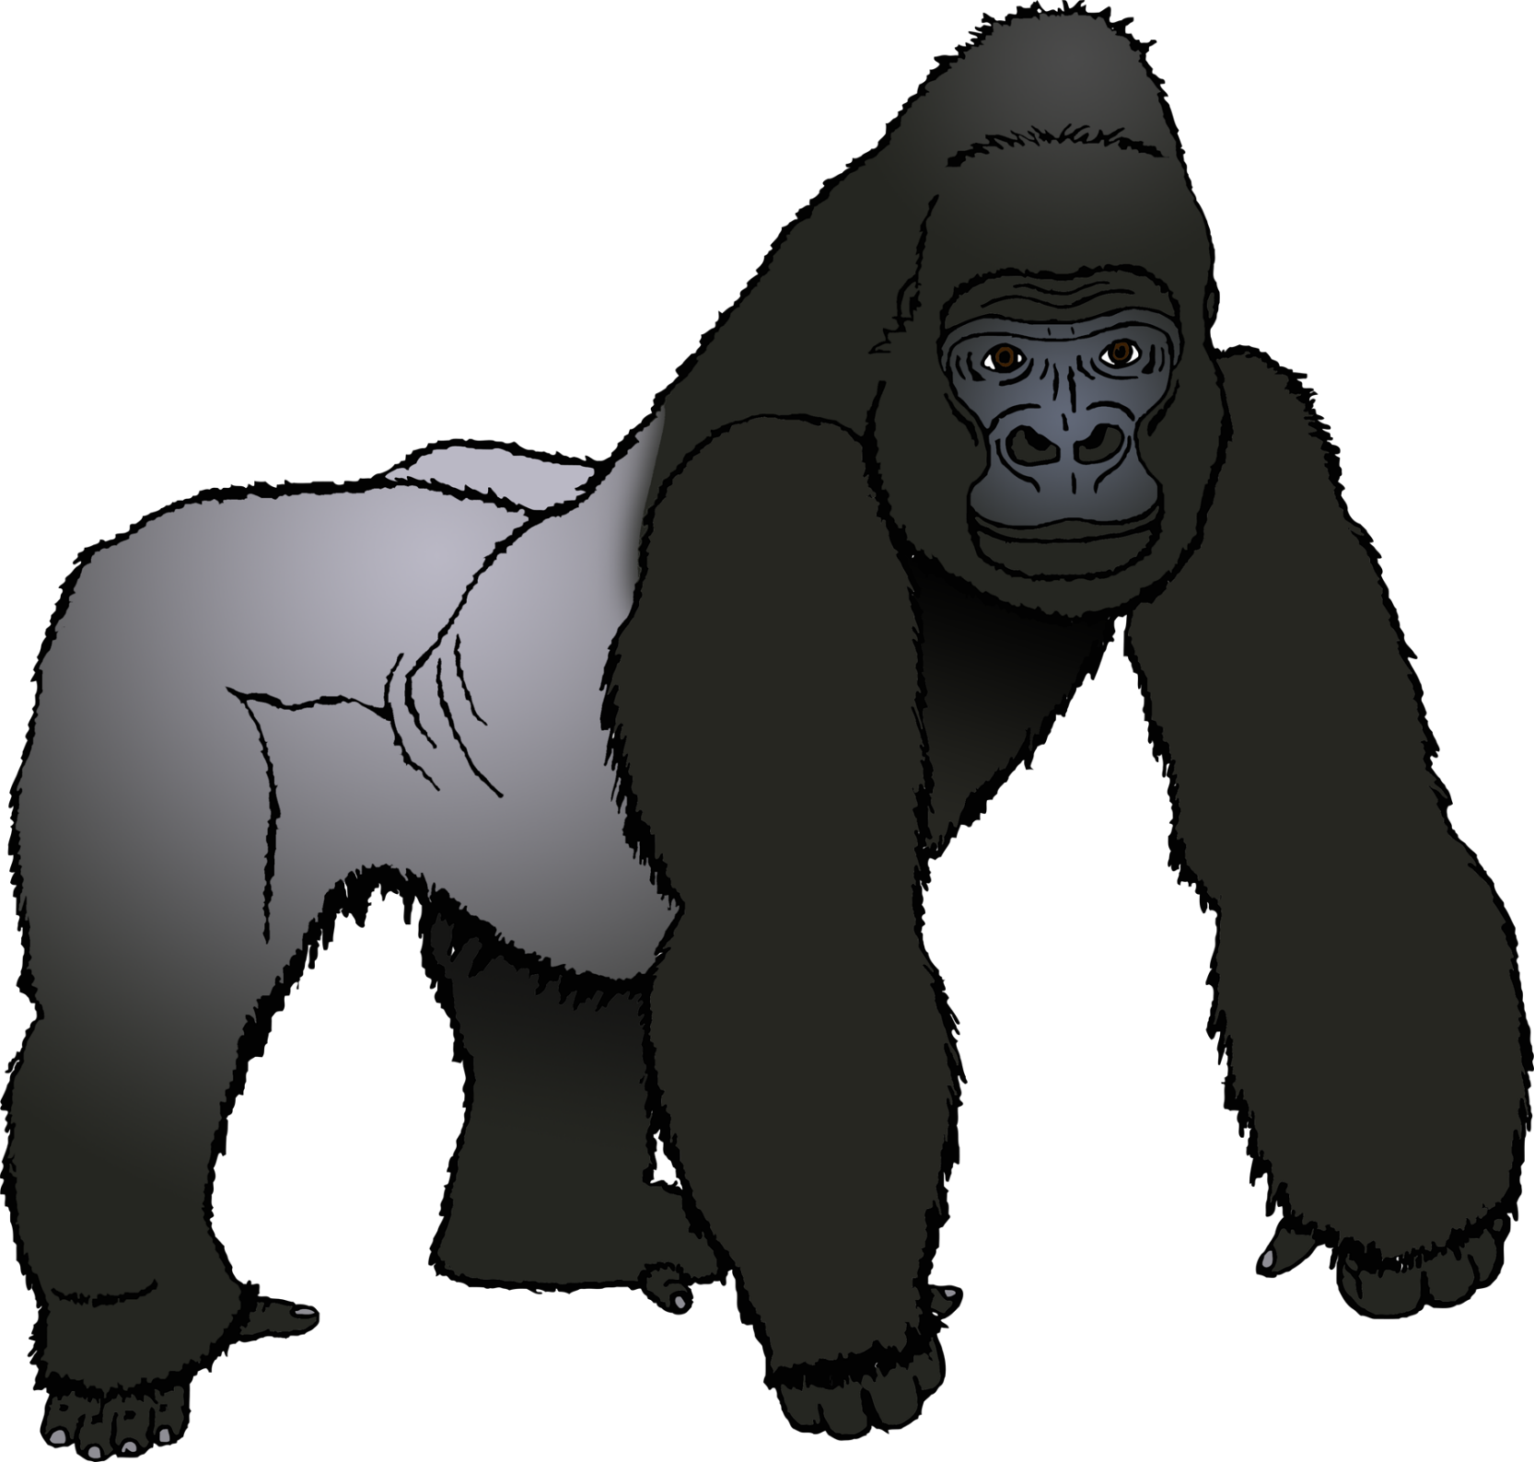

© 2021 Little Owls Resources

**Gorilla**

© 2021 Little Owls Resources

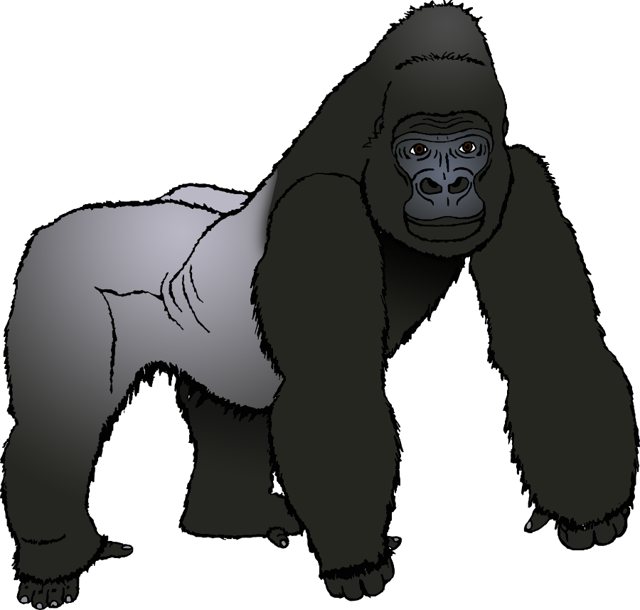

**Gorilla body parts**

© 2021 Little Owls Resources

crest

back

arm

hand

head

eye



**Gorilla body parts**

© 2021 Little Owls Resources

c

b

a

h

h

e



**Gorilla body parts**

© 2021 Little Owls Resources

© 2021 Little Owls Resources

**Draw a Gorilla!**

© 2021 Little Owls Resources

**Draw and write about a Gorilla!**

____________________________________________________

© 2021 Little Owls Resources

**Draw and write about a Gorilla!**

______________________________________________________________________________________________________

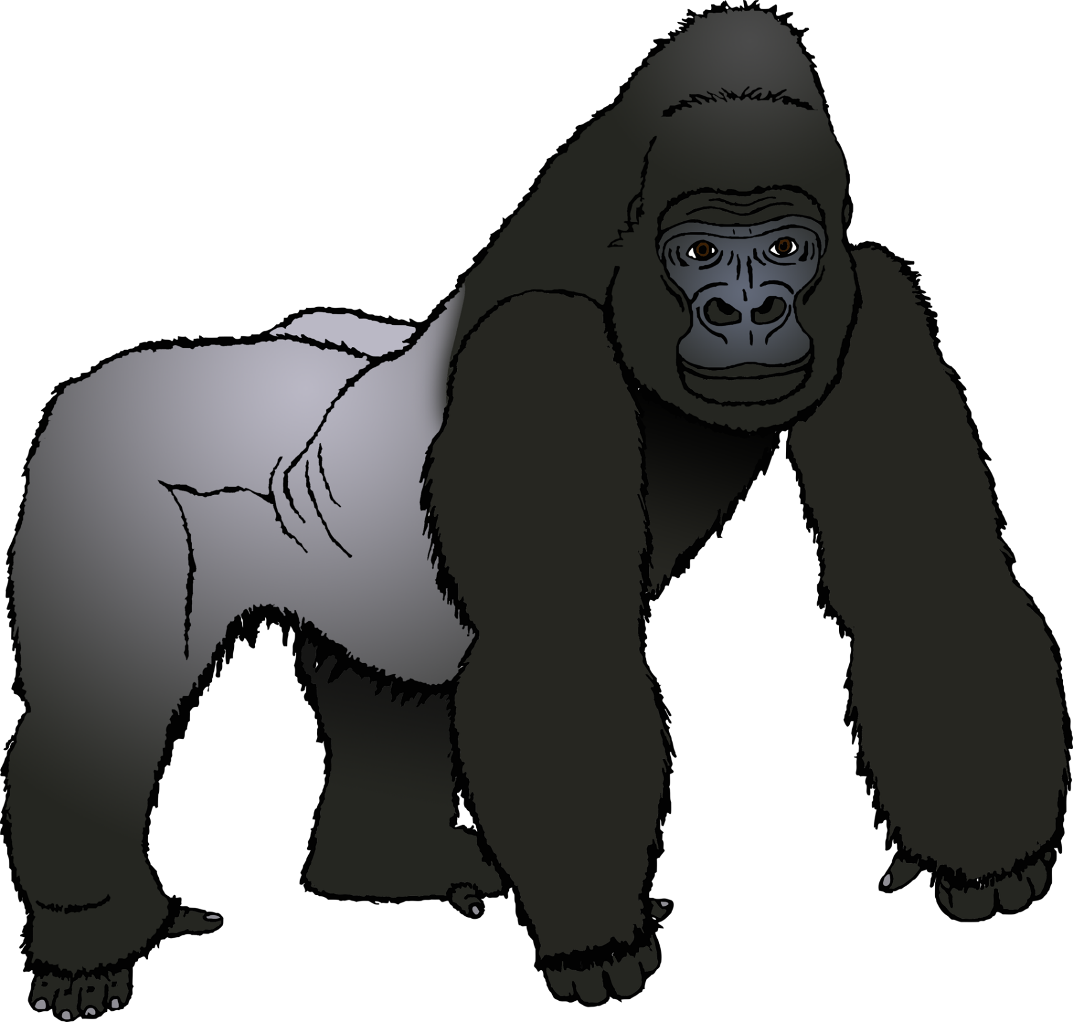

**Gorilla**

© 2021 Little Owls Resources

© 2021 Little Owls Resources

**Gorilla Multimat – Gorilla**

© 2021 Little Owls Resources

**Gorilla Multimat – Gorillas**

© 2021 Little Owls Resources

**Gorilla Multimat – Gorilla and Food**

