© 2020 Little Owls Resources

© 2020 Little Owls Resources

spoon

Goldilocks

full bowl

© 2020 Little Owls Resources

www.littleowlsresources.com

www.littleowlsresources.com

www.littleowlsresources.com

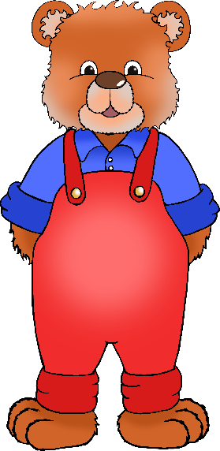

Mummy Bear

Baby Bear

Daddy Bear

© 2020 Little Owls Resources

© 2020 Little Owls Resources

© 2020 Little Owls Resources

© 2020 Little Owls Resources

© 2020 Little Owls Resources

© 2020 Little Owls Resources

bed

empty bowl

chair

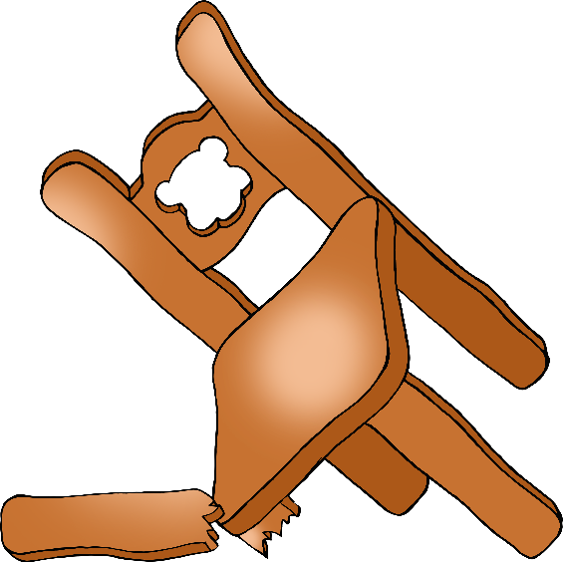

broken chair

© 2020 Little Owls Resources