Goldilocks and the Three Bears Word Mat

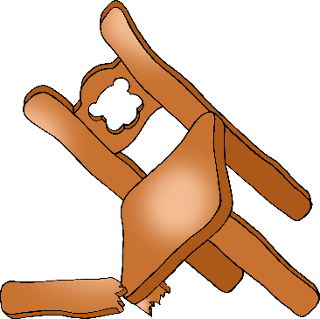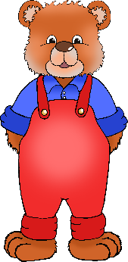

bed

Goldilocks

spoon

Baby Bear

© 2020 Little Owls Resources

broken chair

chair

full bowl

empty bowl

Daddy Bear

Mummy Bear