Blue Bed

© 2020 Little Owls Resources

© 2020 Little Owls Resources

Blue Bed

Blue Bed

© 2020 Little Owls Resources

© 2020 Little Owls Resources

Blue Bed

Chair

© 2020 Little Owls Resources

© 2020 Little Owls Resources

Chair

Chair

© 2020 Little Owls Resources

© 2020 Little Owls Resources

Chair

Red Bed

© 2020 Little Owls Resources

© 2020 Little Owls Resources

Red Bed

Red Bed

© 2020 Little Owls Resources

© 2020 Little Owls Resources

Red Bed

Bowl of Porridge

© 2020 Little Owls Resources

© 2020 Little Owls Resources

Bowl of Porridge

Bowl of Porridge

© 2020 Little Owls Resources

Owls Resources

© 2020 Little Owls Resources

Bowl of Porridge

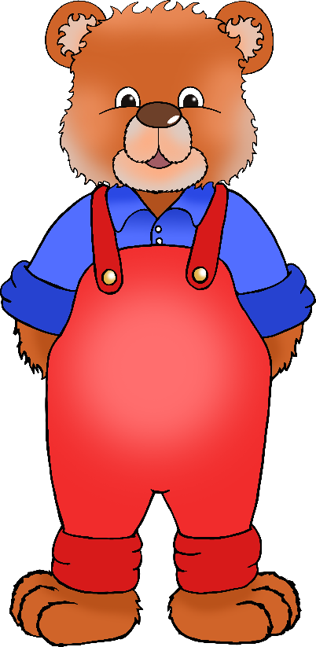

Daddy Bear

© 2020 Little Owls Resources

© 2020 Little Owls Resources

Daddy Bear



Daddy Bear

© 2020 Little Owls Resources

© 2020 Little Owls Resources

Daddy Bear

Green Bed

© 2020 Little Owls Resources

© 2020 Little Owls Resources

© 2020 Little Owls Resources

Green Bed

Green Bed

© 2020 Little Owls Resources

© 2020 Little Owls Resources

Green Bed

Goldilocks

© 2020 Little Owls Resources

© 2020 Little Owls Resources

Goldilocks

Goldilocks

© 2020 Little Owls Resources

© 2020 Little Owls Resources

Goldilocks

Mummy Bear

© 2020 Little Owls Resources

© 2020 Little Owls Resources

Mummy Bear

Mummy Bear

© 2020 Little Owls Resources

© 2020 Little Owls Resources

Owls Resources

Mummy Bear

Spoon

© 2020 Little Owls Resources

© 2020 Little Owls Resources

Spoon

Spoon

© 2020 Little Owls Resources

© 2020 Little Owls Resources

Spoon

Baby Bear

© 2020 Little Owls Resources

© 2020 Little Owls Resources

Baby Bear

Baby Bear

© 2020 Little Owls Resources

Baby Bear

© 2020 Little Owls Resources

© 2019 Little Owls Resources