**Goldilocks and the Three Bears** Memory Game

Lay out the cards face down and then take it in turns to try and find matching pairs!

© 2020 Little Owls Resources

© 2020 Little Owls Resources

© 2020 Little Owls Resources

© 2020 Little Owls Resources

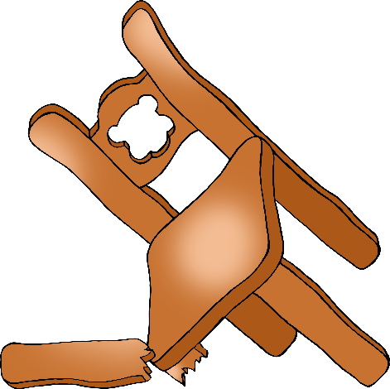

© 2020 Little Owls Resources

© 2020 Little Owls Resources

© 2020 Little Owls Resources

© 2020 Little Owls Resources

© 2020 Little Owls Resources

© 2020 Little Owls Resources

© 2020 Little Owls Resources

© 2020 Little Owls Resources

© 2020 Little Owls Resources

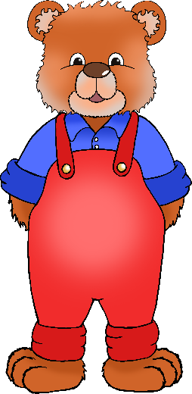

© 2020 Little Owls Resources

© 2020 Little Owls Resources

© 2020 Little Owls Resources

© 2020 Little Owls Resources

© 2020 Little Owls Resources

© 2020 Little Owls Resources

© 2020 Little Owls Resources

© 2020 Little Owls Resources

