**Goldilocks**

**and the**

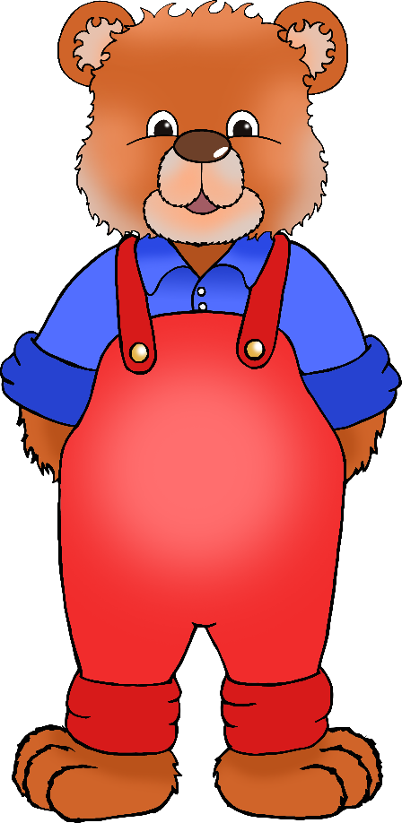

**Three Bears**

© 2020 Little Owls Resources

**Kippur**

Someone's been eating my porridge!

Someone's been sitting in my chair!

Someone's been sleeping in my bed!