© 2023 Little Owls Resources

**My Favourite Part**

The Gingerbread Man

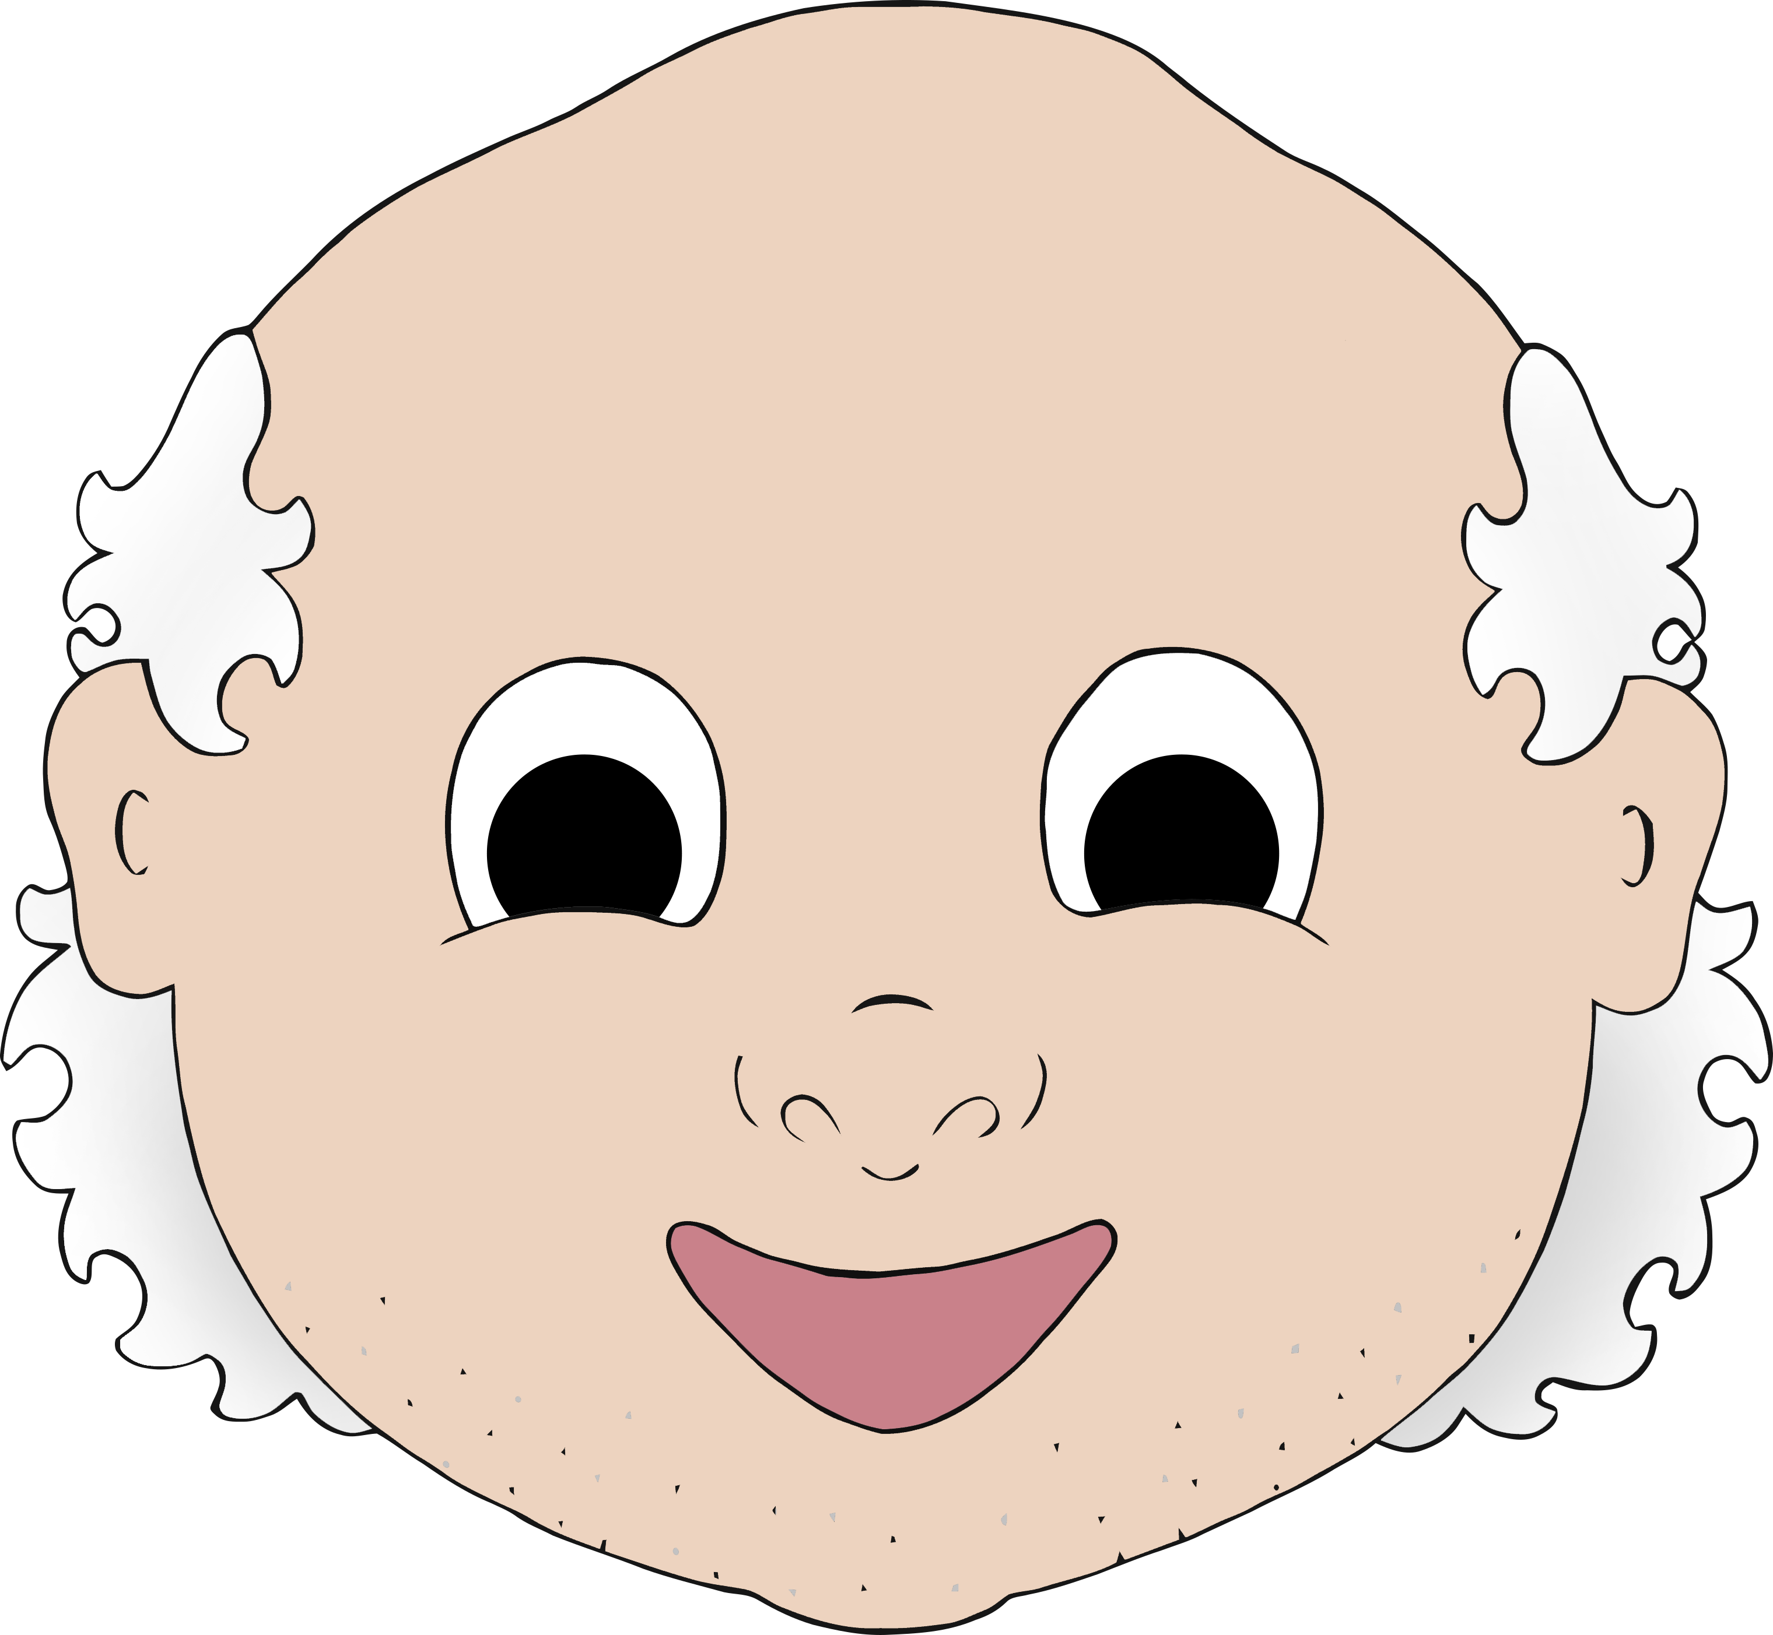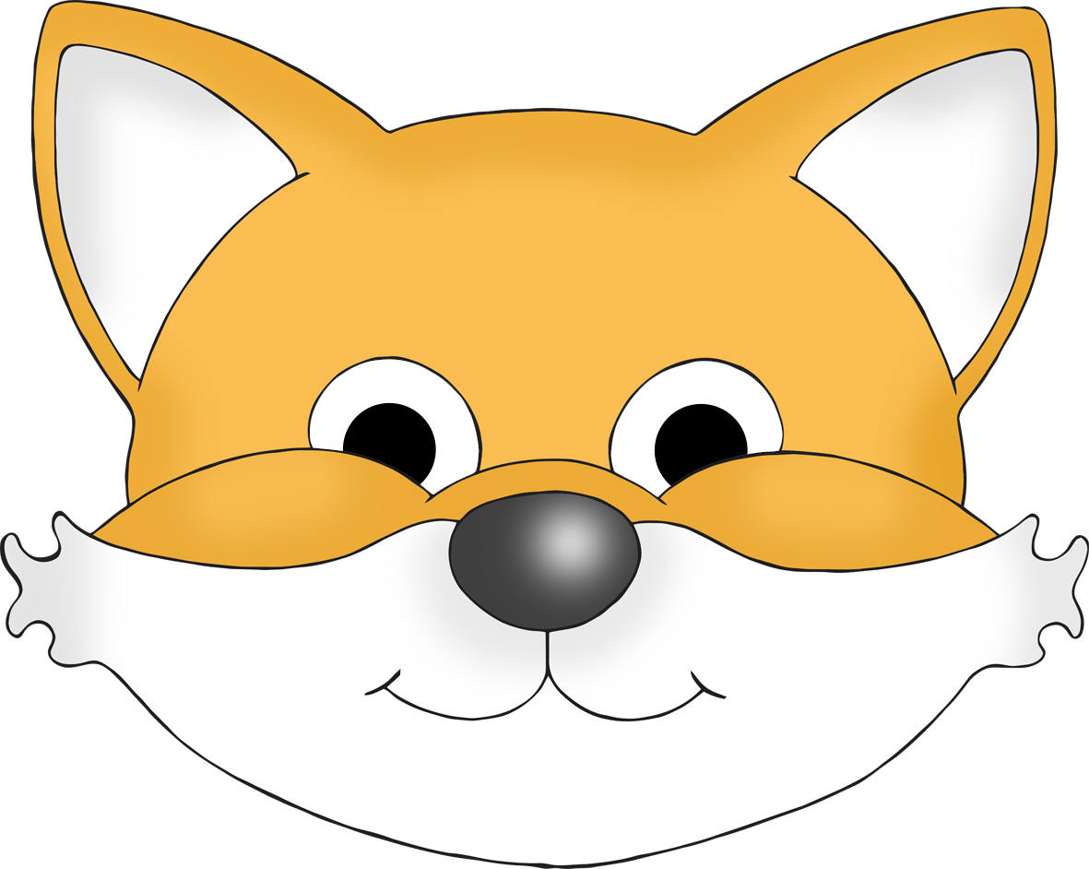

____________________________________________________________________________________

© 2023 Little Owls Resources

**My Favourite Part**

The Gingerbread Man



________________________________________________________________________________________________________________________________________________________________________________________________

© 2023 Little Owls Resources

**My Favourite Part**

The Gingerbread Man



© 2023 Little Owls Resources

**My Favorite Part**

The Gingerbread Man



____________________________________________________________________________________

© 2023 Little Owls Resources

**My Favorite Part**

The Gingerbread Man



© 2023 Little Owls Resources

**My Favorite Part**

The Gingerbread Man



________________________________________________________________________________________________________________________________________________________________________________________________