**My Favourite Character**

The Gingerbread Man

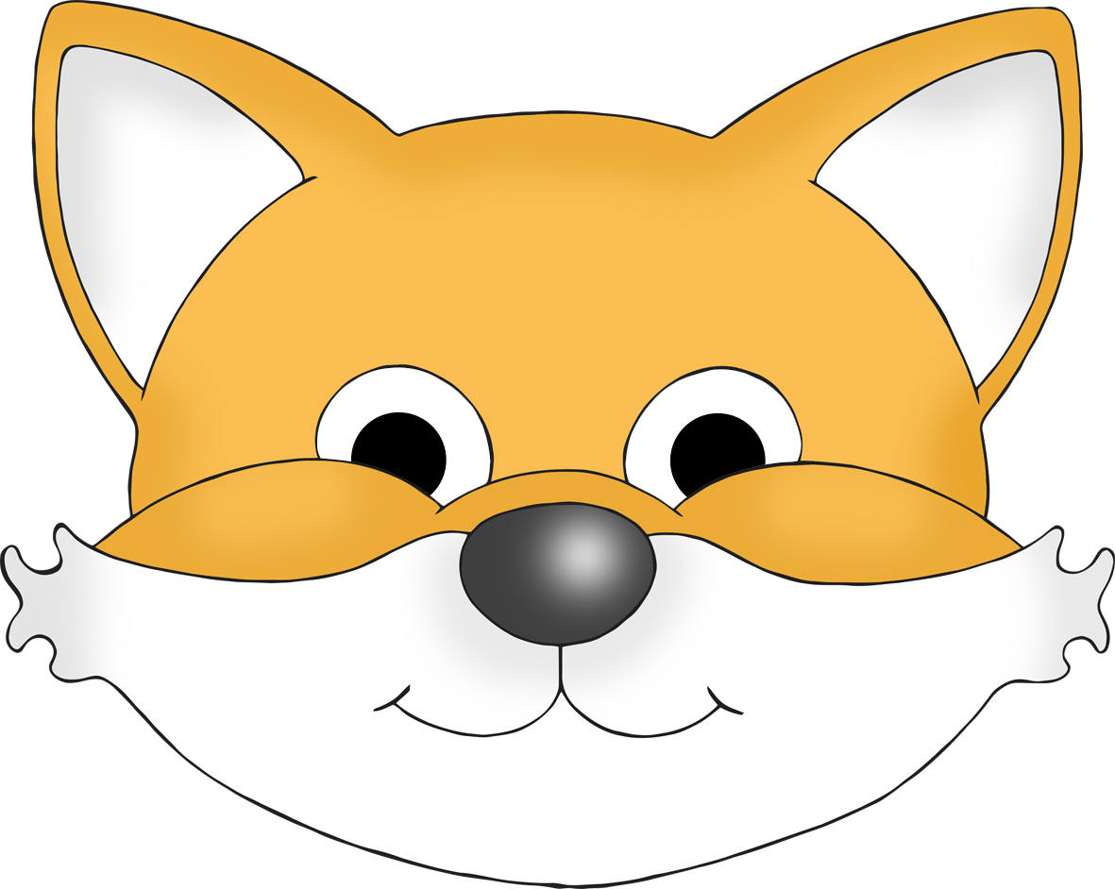

© 2023 Little Owls Resources

________________________________________________________________________________________________________

____________________________

© 2023 Little Owls Resources

© 2020 Little Owls Resources

**My Favourite Character**

The Gingerbread Man



© 2023 Little Owls Resources

**My Favourite Character**

The Gingerbread Man



**My Favorite Character**

The Gingerbread Man



________________________________________________________________________________________________________

© 2023 Little Owls Resources

____________________________

© 2023 Little Owls Resources

© 2020 Little Owls Resources

**My Favorite Character**

The Gingerbread Man



**My Favorite Character**

The Gingerbread Man



© 2023 Little Owls Resources