**The Gingerbread Man on the baking tray.**

© 2023 Little Owls Resources

**The Gingerbread Man escapes from the oven.**

© 2023 Little Owls Resources

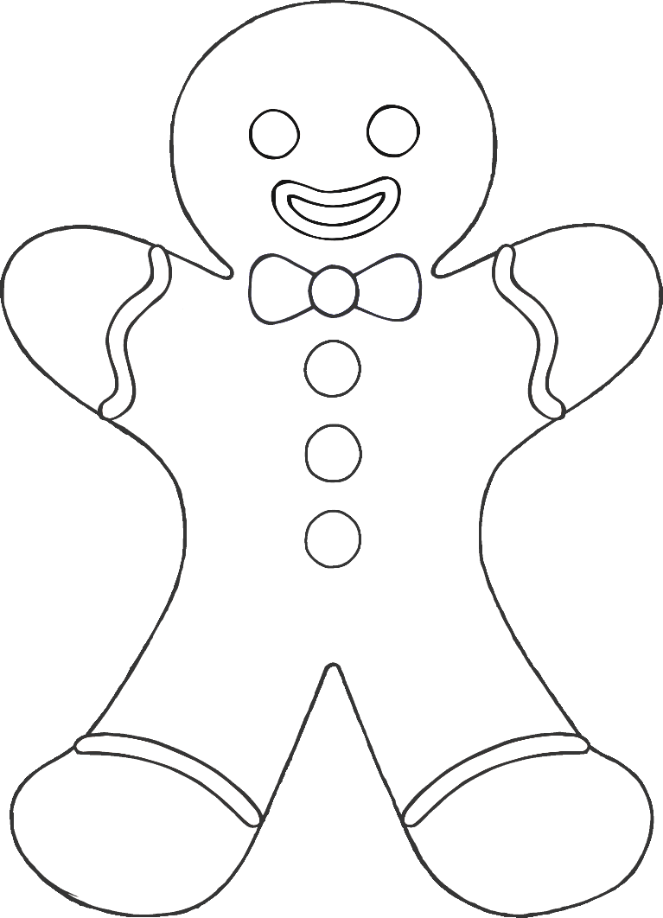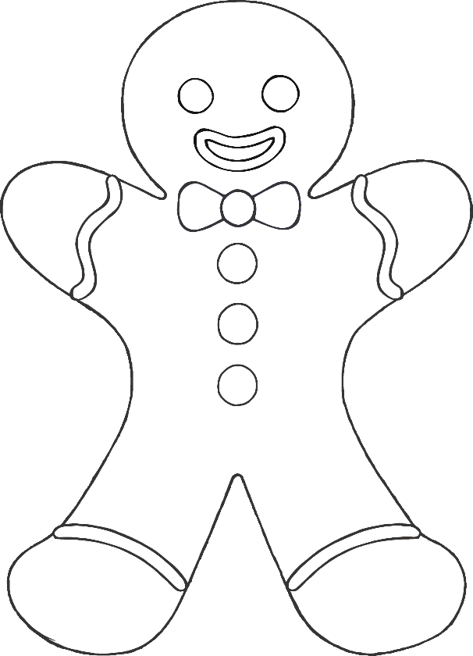

**old woman**

© 2023 Little Owls Resources

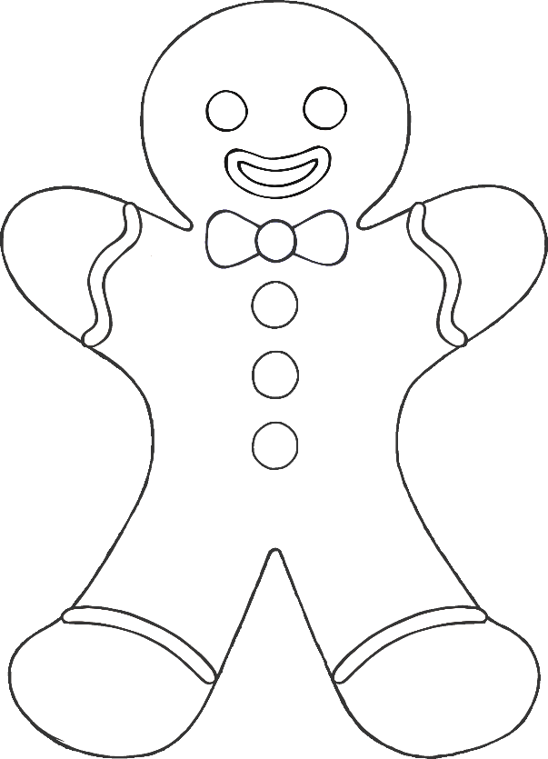

**old man**

© 2023 Little Owls Resources

**dog**

© 2023 Little Owls Resources

**cat**

© 2023 Little Owls Resources

**pig**

© 2023 Little Owls Resources

**fox**

© 2023 Little Owls Resources