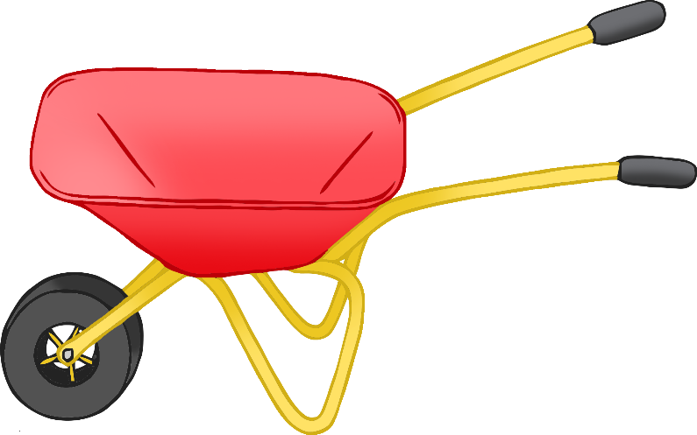

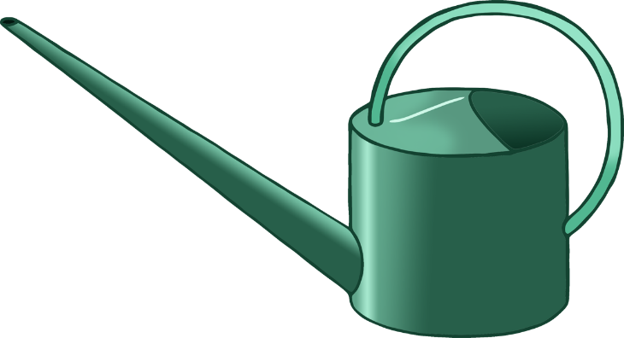

tyre planter

**w**atering can

**w**heelbarro**w**

© 2023 Little Owls Resources

© 2023 Little Owls Resources

© 2023 Little Owls Resources

garden tro**w**el

box planter

broom

© 2023 Little Owls Resources

© 2023 Little Owls Resources

Resources

© 2023 Little Owls Resources

© 2023 Little Owls Resources

© 2023 Little Owls Resources

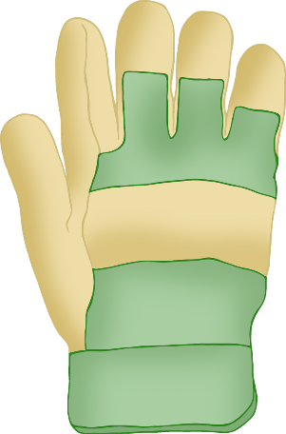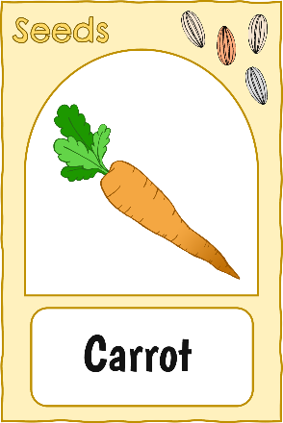

gardening gloves

seed packets

plant pot

small garden rake

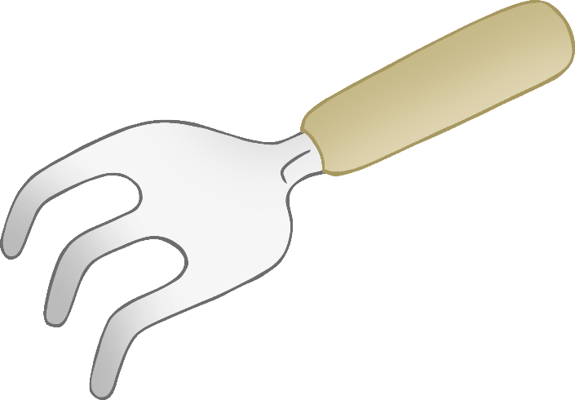

© 2023 Little Owls Resources

© 2023 Little Owls Resources

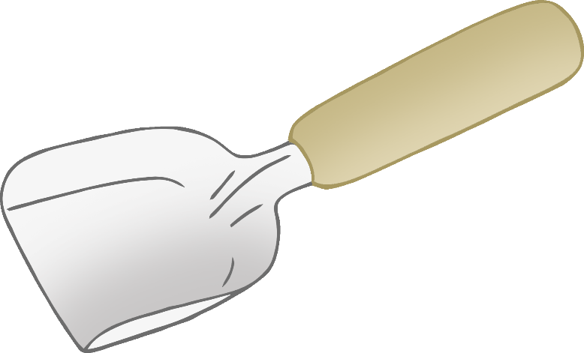

flo**w**ers

small garden spade

© 2023 Little Owls Resources