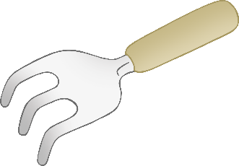

**Gardening Word Mat**

**w**heelbarro**w**

seed packets

plant pot

broom

tyre planter

flo**w**ers

garden gloves

**w**atering can

box planter

© 2023 Little Owls Resources

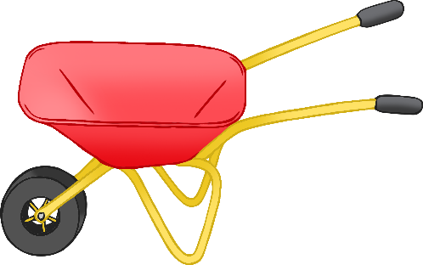

small garden rake

small garden tro**w**el

small garden spade