**Gardening**

Silhouette Match Puzzle

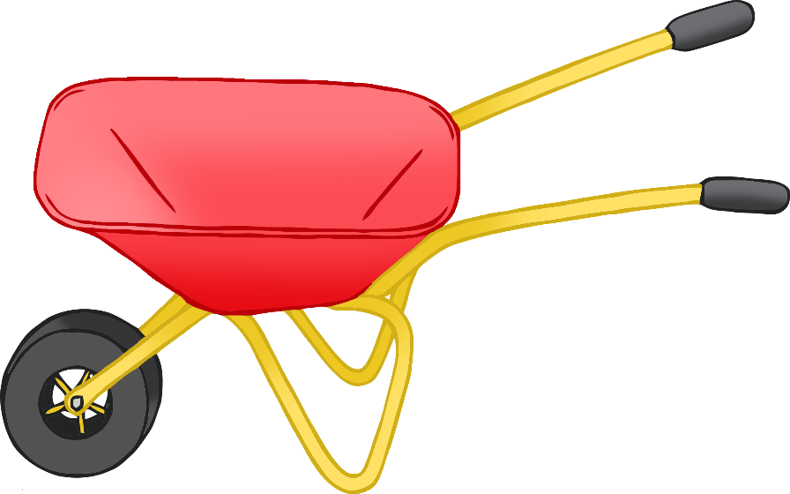

This matching puzzle has a different connection for each set to allow the children to self-correct.

© 2023 Little Owls Resources

© 2023 Little Owls Resources

© 2023 Little Owls Resources

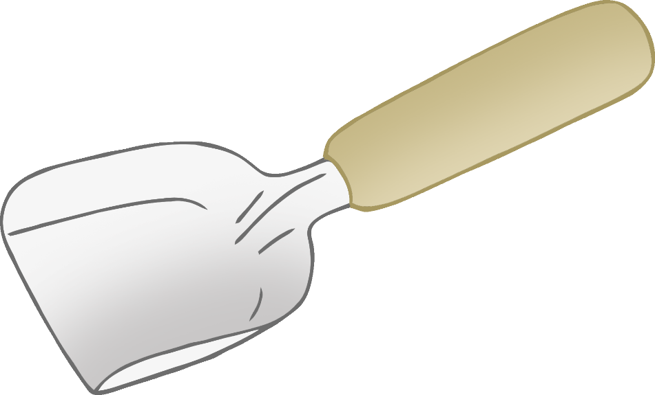

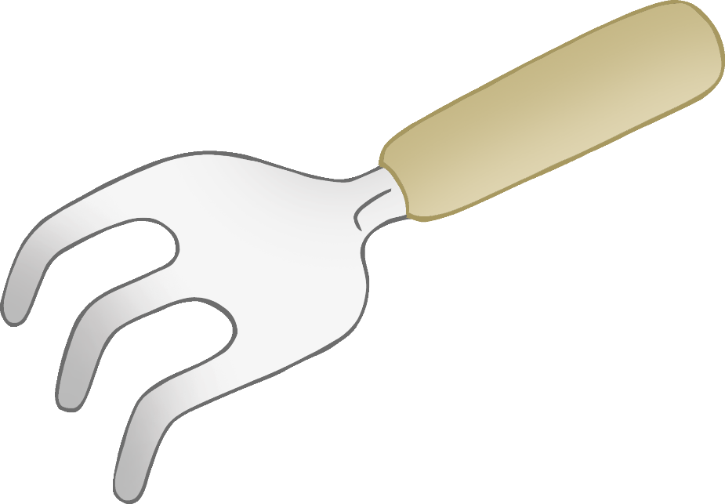

© 2023 Little Owls Resources

© 2023 Little Owls Resources

© 2023 Little Owls Resources

© 2023 Little Owls Resources

© 2023 Little Owls Resources

© 2023 Little Owls Resources

