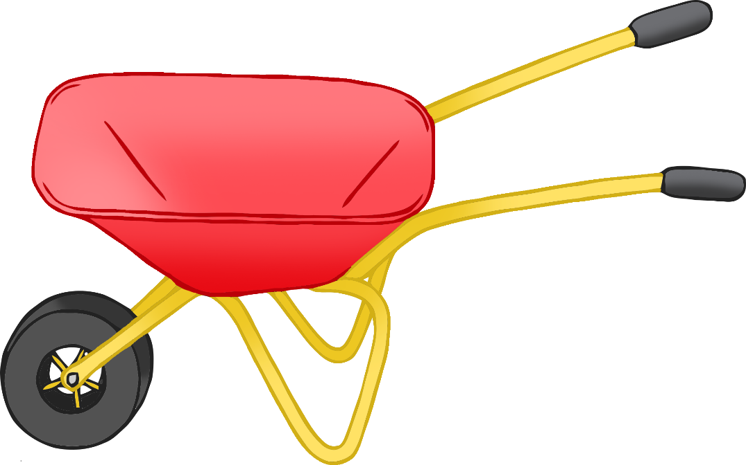

**Gardening**

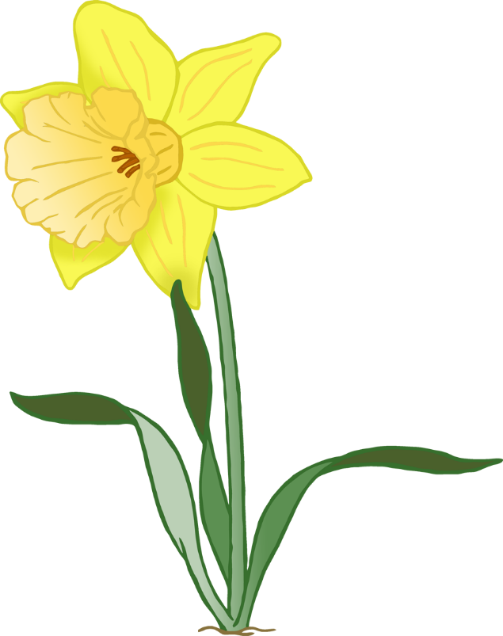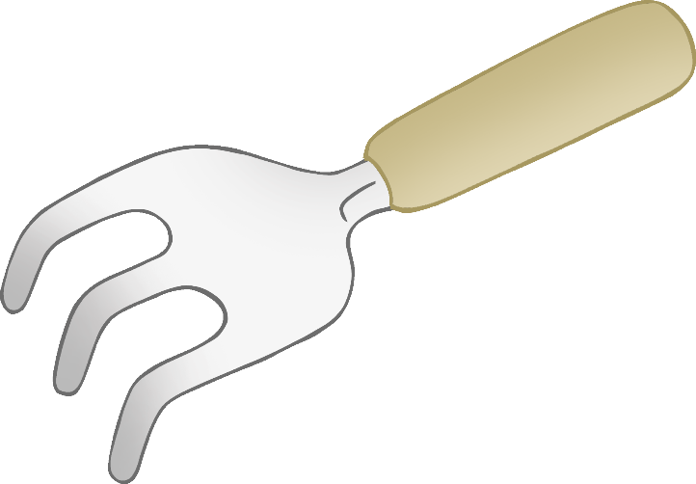

© 2023 Little Owls Resources