© 2021 Little Owls Resources

© 2021 Little Owls Resources

© 2021 Little Owls Resources

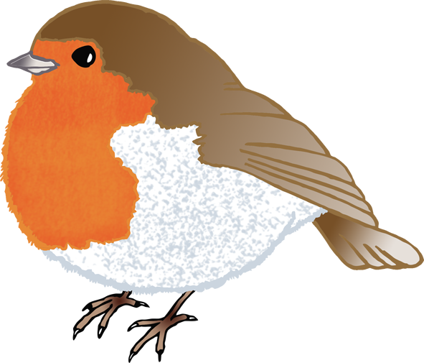

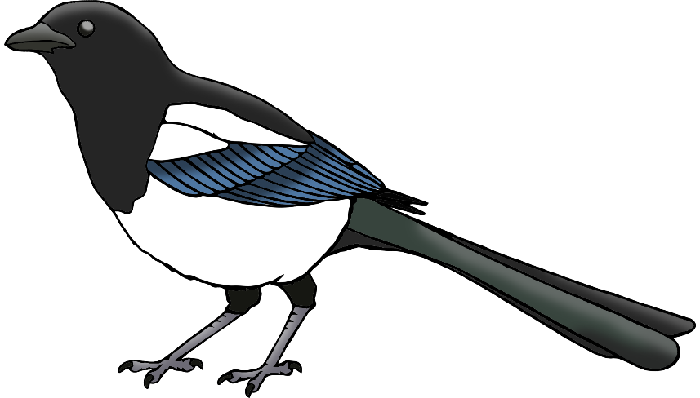

robin

pigeon

magpie

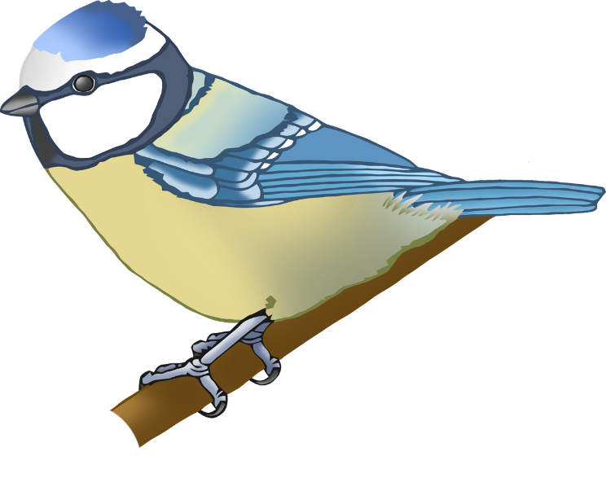

www.littleowlsresources.com

www.littleowlsresources.com

www.littleowlsresources.com

© 2021 Little Owls Resources

© 2021 Little Owls Resources

blackbird

blue tit

© 2021 Little Owls Resources

© 2021 Little Owls Resources

© 2021 Little Owls Resources



Robin

Pigeon

Magpie

Blue Tit

Blackbird

© 2021 Little Owls Resources

© 2021 Little Owls Resources

www.littleowlsresources.com

www.littleowlsresources.com

www.littleowlsresources.com