**Garden Birdwatch Mat**

robin

© 2021 Little Owls Resources

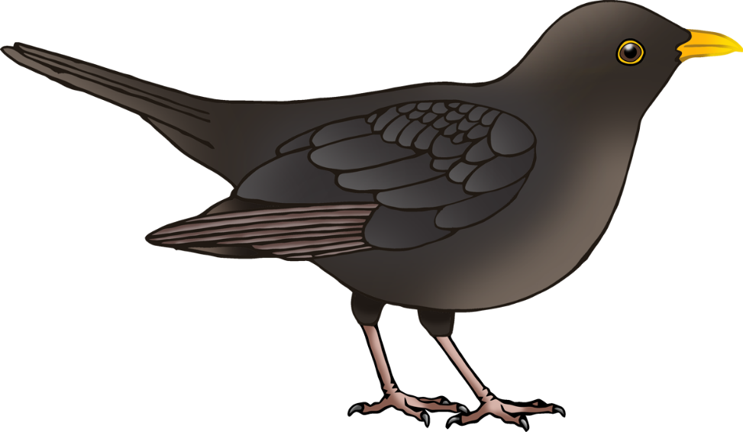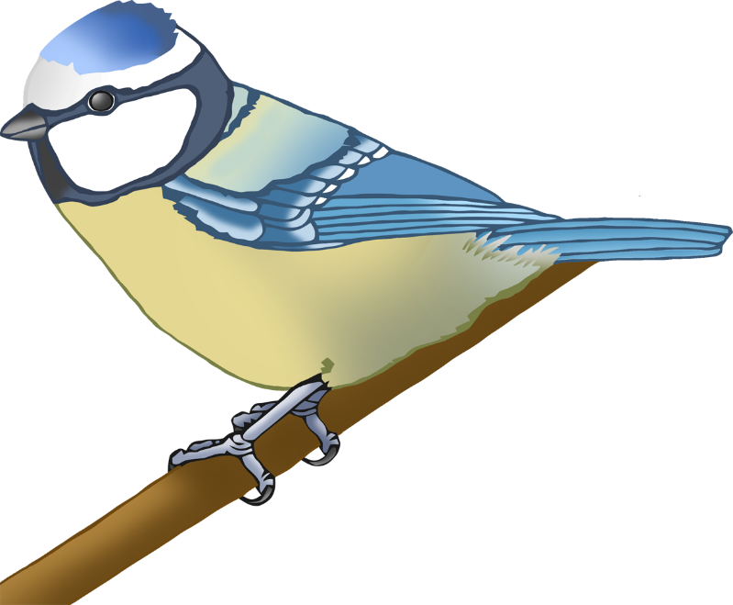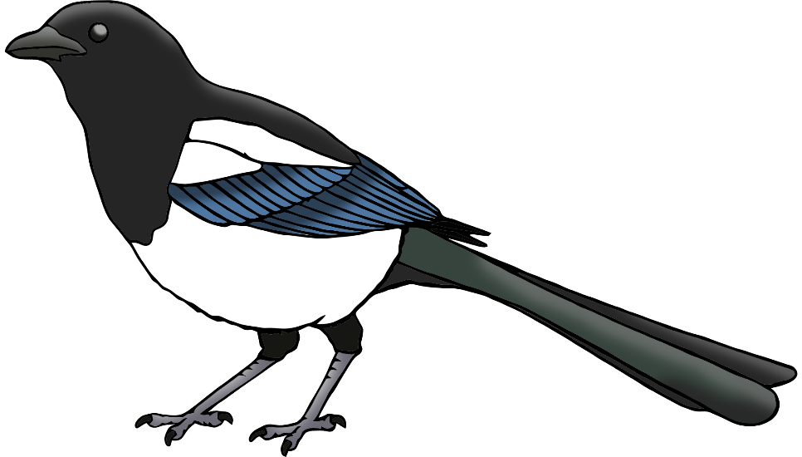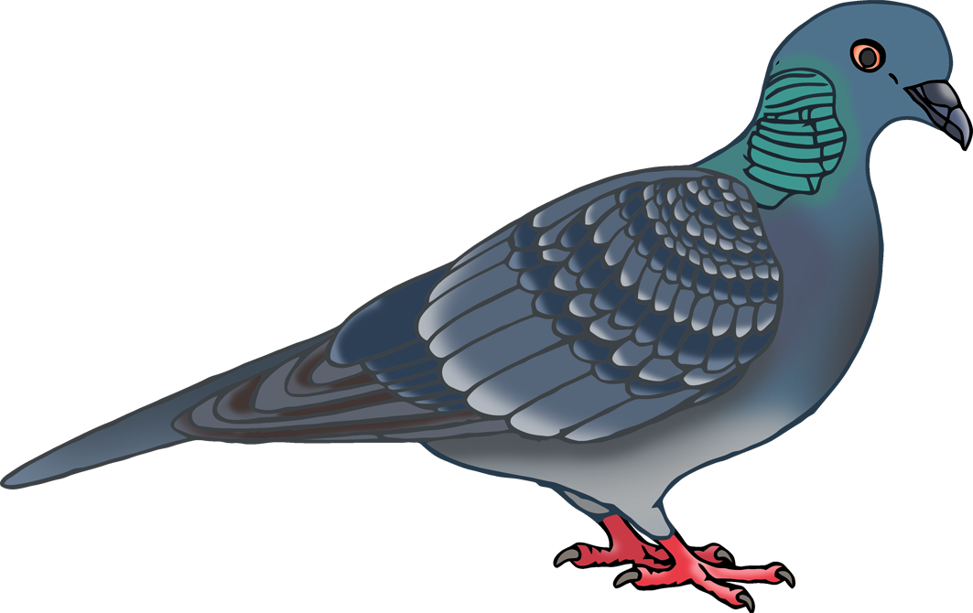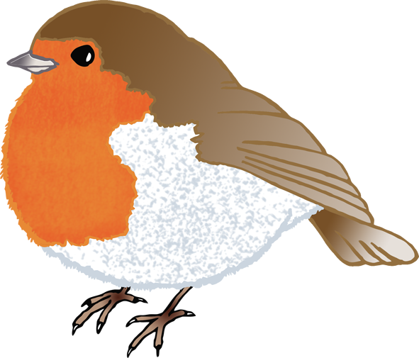

pigeon

magpie

blackbird

blue tit

**Garden Birdwatch Mat**

Robin

© 2021 Little Owls Resources



Pigeon

Magpie

Blackbird

Blue Tit