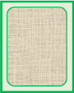

Help the garden birds find their eggs!

Game for five players.

Each player has a large mat with a bird on. Takes turns to turn a small card over. If the egg matches the one on your mat, place it in the first space. If it is not a match put the card back where you found it.

The first player to get five correct eggs is the winner!

**Garden Birdwatch Egg Match**

© 2021 Little Owls Resources

© 2021 Little Owls Resources

1

2

3

4

5

Blackbird

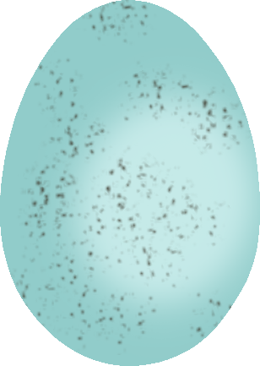

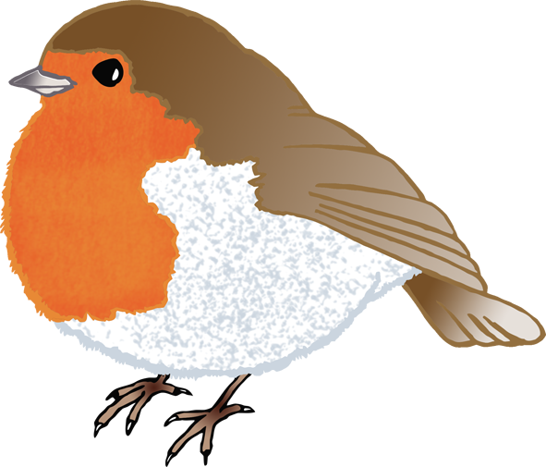

© 2021 Little Owls Resources

1

2

3

4

5

Robin

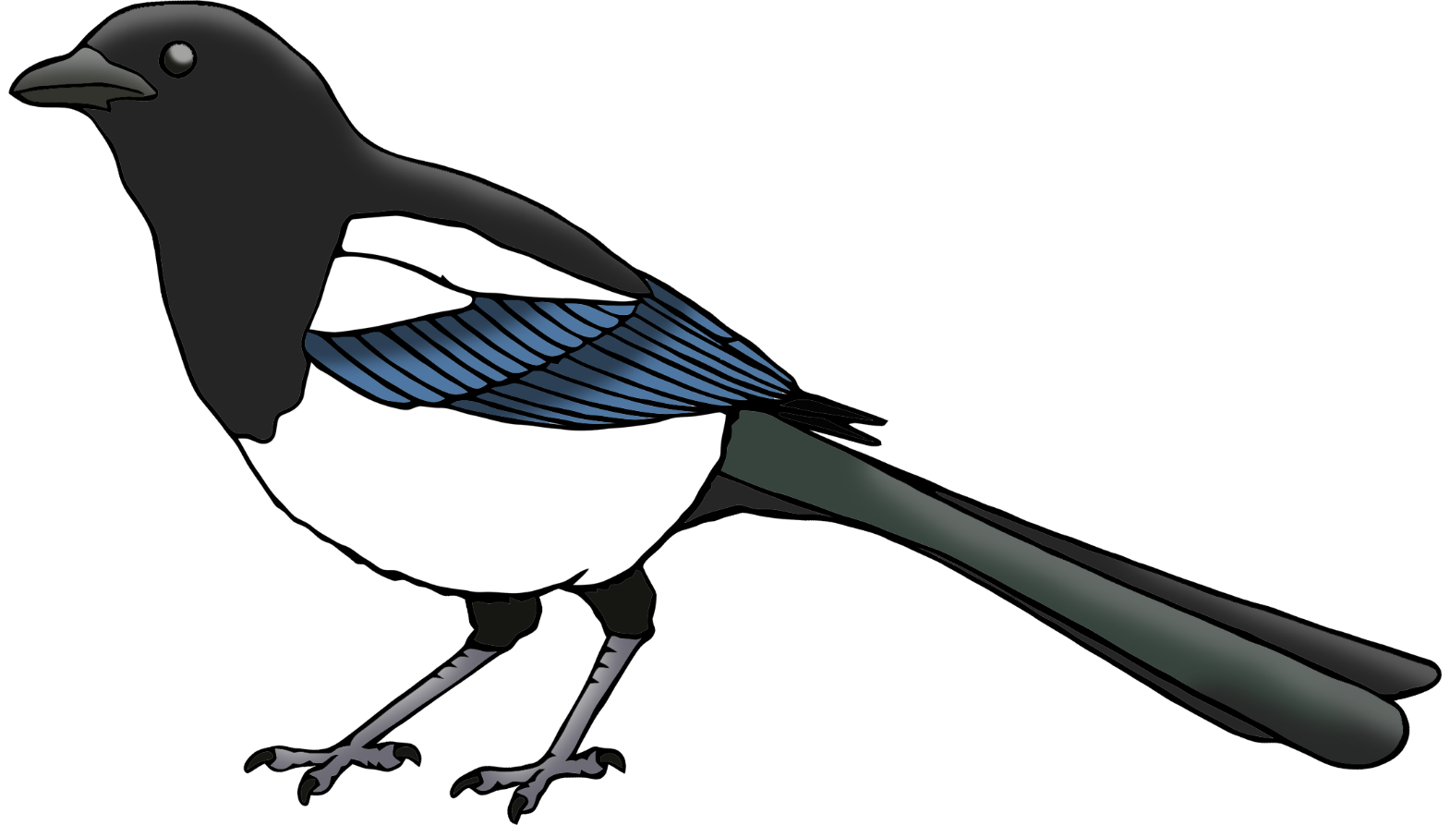

© 2021 Little Owls Resources

1

2

3

4

5

Magpie

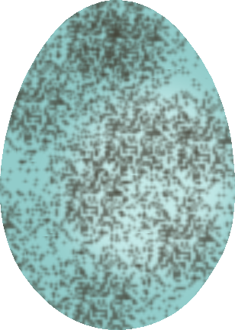

© 2021 Little Owls Resources

1

2

3

4

5

Pigeon

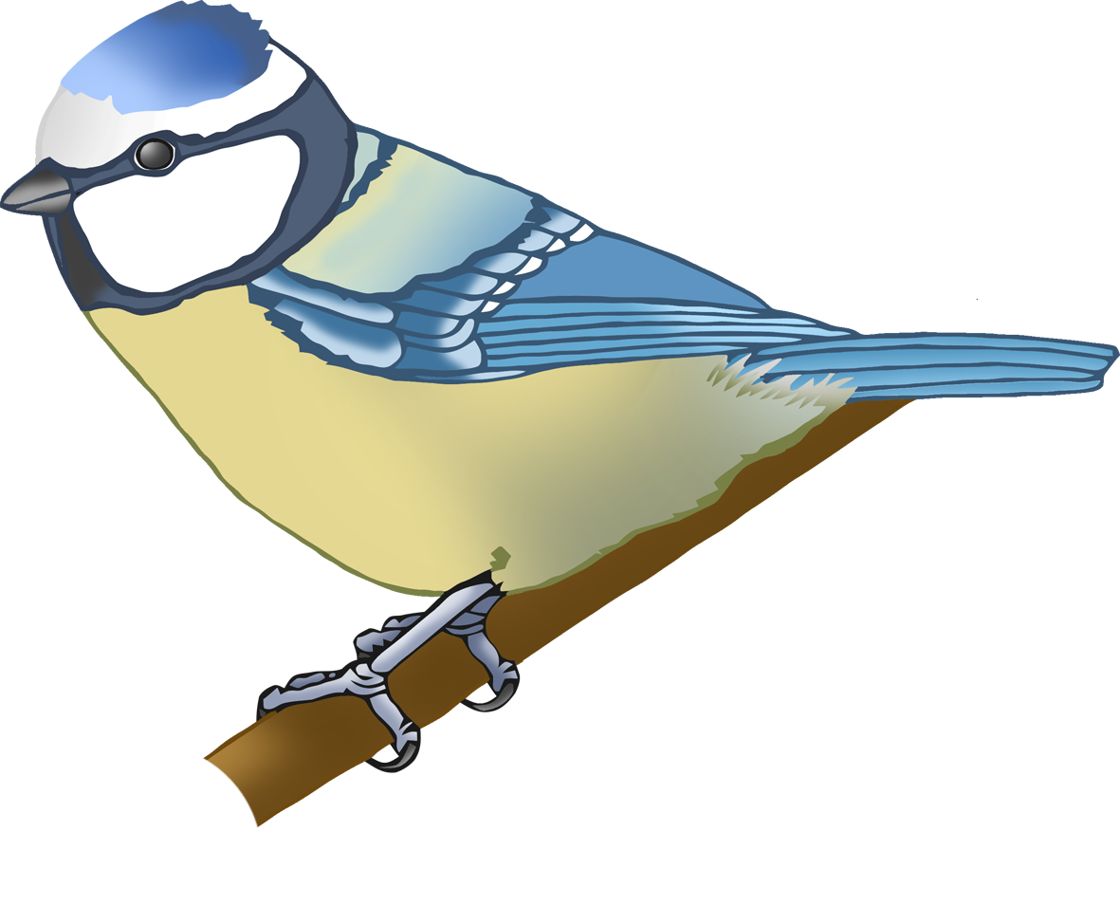

© 2021 Little Owls Resources

1

2

3

4

5

Blue Tit



