**Garden Birdwatch Checklist** ✔️✔️✔️

© 2021 Little Owls Resources

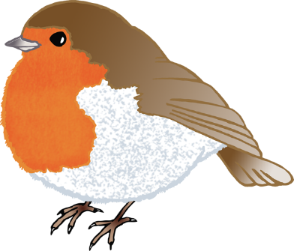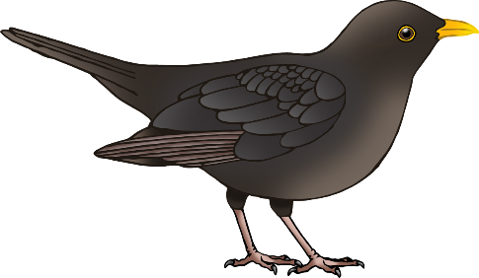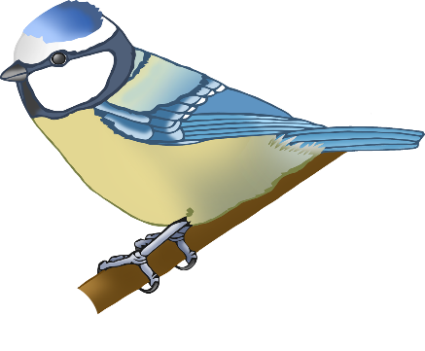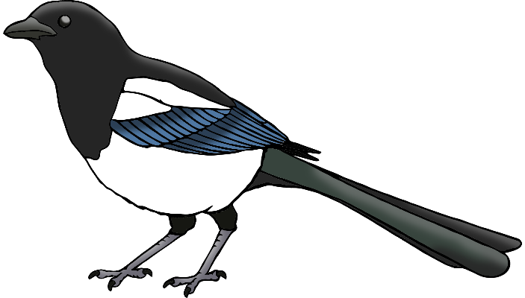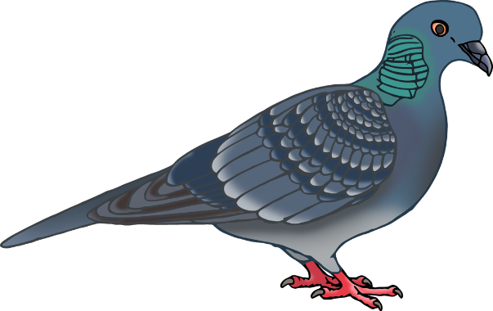

robin

blackbird

magpie

blue tit

pigeon

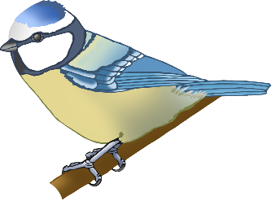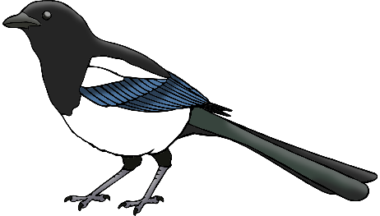

magpie

blackbird

robin

pigeon

blue tit

**Garden Birdwatch Checklist** ✔️✔️✔️

© 2021 Little Owls Resources