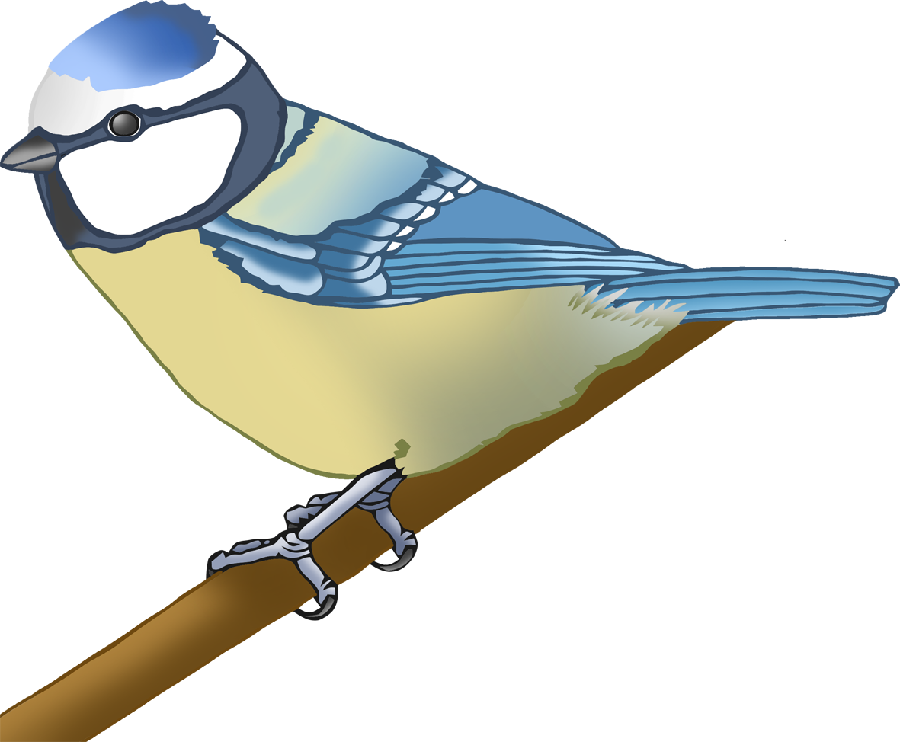

**Garden Birds Pom Pom Mat**

© 2020 Little Owls Resources

**Garden Birds Pom Pom Mat**

© 2020 Little Owls Resources

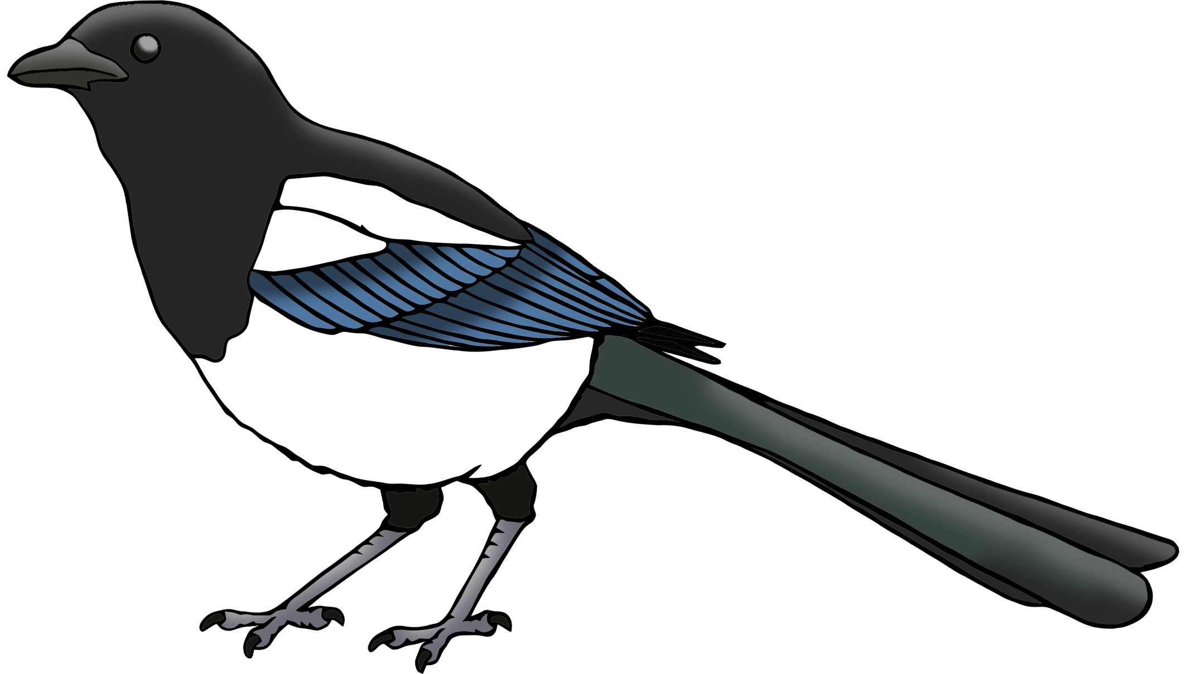

**Garden Birds Pom Pom Mat**

© 2020 Little Owls Resources

**Garden Birds Pom Pom Mat**

© 2020 Little Owls Resources

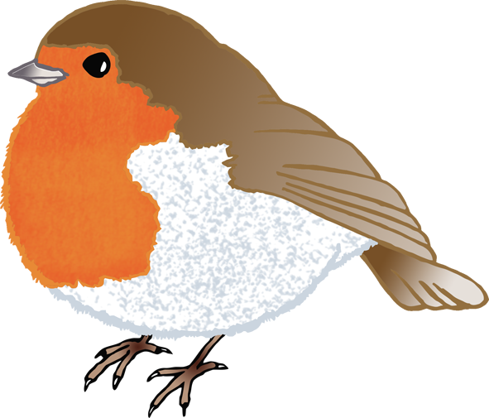

**Garden Birds Pom Pom Mat**

© 2020 Little Owls Resources