**Fruit and**

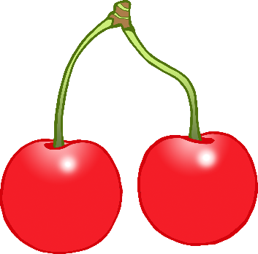

**Vegetables**

© 2020 Little Owls Resources