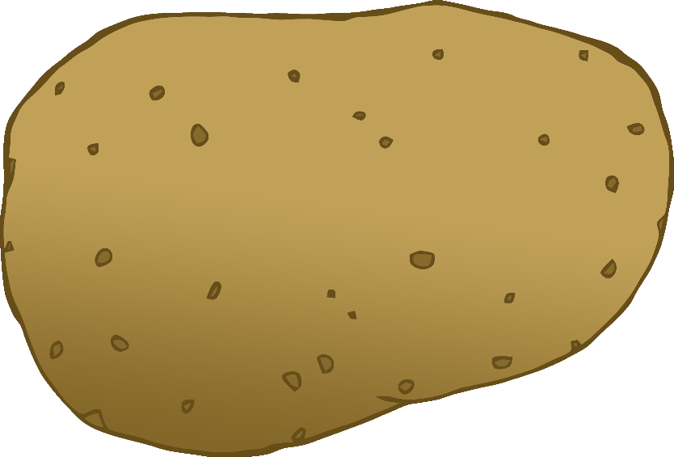

potato

картопля

(kar-top-lah)

English/Ukrainian

© 2022 Little Owls Resources

tomato

помідор

(pom-ee-dor)

English/Ukrainian

© 2022 Little Owls Resources

carrot

морква

(mork-vah)

English/Ukrainian

© 2022 Little Owls Resources

lettuce

салат

(suh-lat)

English/Ukrainian

© 2022 Little Owls Resources

cucumber

огірок

(oh-hih-rok)

English/Ukrainian

© 2022 Little Owls Resources

apple

яблуко

(yab-luk-oh)

English/Ukrainian

© 2022 Little Owls Resources

orange

апельсин

(app-el-sin)

English/Ukrainian

© 2022 Little Owls Resources

banana

банан

(bun-un)

English/Ukrainian

© 2022 Little Owls Resources

strawberry

полуниця

(poh-loh-neets-yah)

English/Ukrainian

© 2022 Little Owls Resources

peach

персик

(p-urr-sic)

English/Ukrainian

© 2022 Little Owls Resources