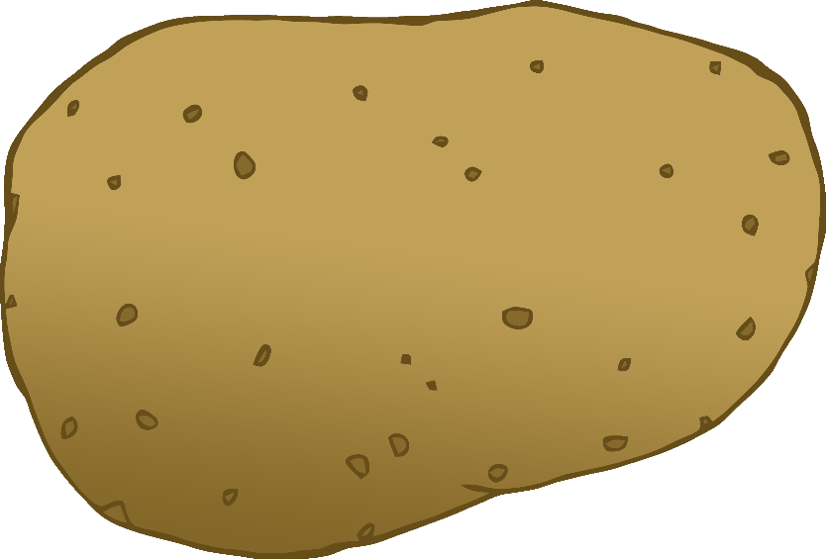

English/Spanish

© 2020 Little Owls Resources

tomato

tomate

(toh-mar-tay)

English/Spanish

© 2020 Little Owls Resources

potato

patata

(pa-ta-ta)

carrot

zanahoria

(sa-na-hor-ya)

English/Spanish

© 2020 Little Owls Resources

lettuce

lechuga

(lay-choo-gah)

English/Spanish

© 2020 Little Owls Resources

cucumber

pepino

(peh-pee-noh)

English/Spanish

© 2020 Little Owls Resources

apple

manzana

(man-sa-na)

English/Spanish

/Portuguese

English/Portuguese

English/Portuguese

English/Portuguese

English/Portuguese

English/Portuguese

English/Portuguese

English/Portuguese

© 2020 Little Owls Resources

orange

naranja

(nah-ran-hah)

English/Spanish

© 2020 Little Owls Resources

banana

plátano

(plat-a-noh)

English/Spanish

© 2020 Little Owls Resources

strawberry

fresa

(fray-sah)

English/Spanish

© 2020 Little Owls Resources

peach

durazno

(doo-rass-noh)

English/Spanish

© 2020 Little Owls Resources