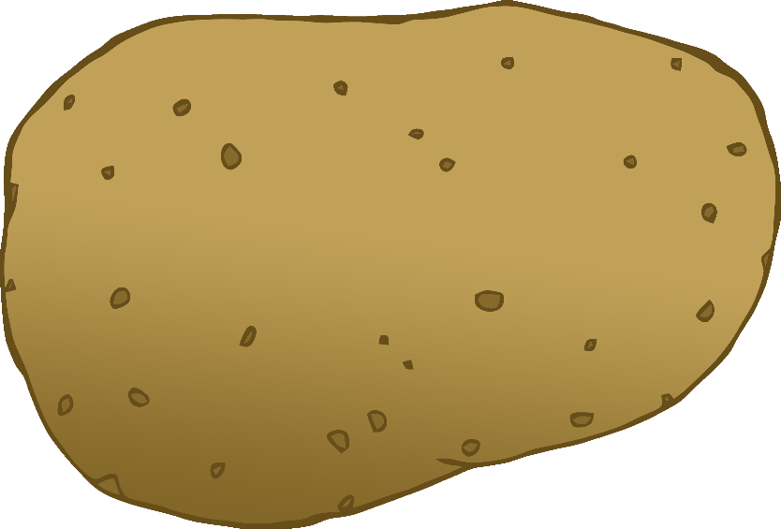

potato

картошка

(kar-tosh-kuh)

English/Russian

© 2020 Little Owls Resources

tomato

помидор

(pom-ee-dor)

English/Russian

© 2020 Little Owls Resources

carrot

морковь

(mor-koff)

English/Russian

© 2020 Little Owls Resources

lettuce

салат

(salat)

English/Russian

© 2020 Little Owls Resources

cucumber

огурец

(og-oo-ree-ets)

English/Russian

© 2020 Little Owls Resources

apple

яблоко

(yab-luk-uh)

English/Russian

© 2020 Little Owls Resources

orange

апельсин

(app-el-sin)

English/Russian

© 2020 Little Owls Resources

banana

Банан

(bun-un)

English/Russian

© 2020 Little Owls Resources

strawberry

клубника

(kloob-nee-kuh)

English/Russian

© 2020 Little Owls Resources

peach

персик

(p-air-sic)

English/Russian

© 2020 Little Owls Resources