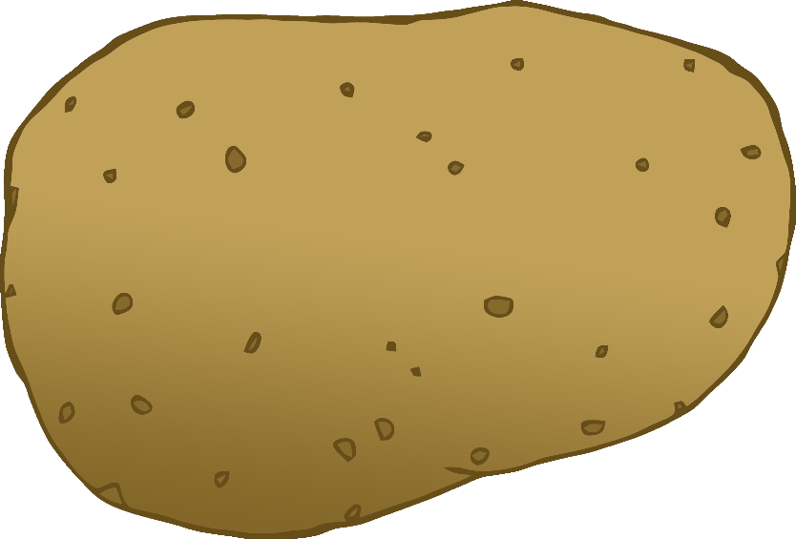

English/Punjabi

© 2020 Little Owls Resources

tomato

ਟਮਾਟਰ

(tah-mar-tur)

English/Punjabi

© 2020 Little Owls Resources

potato

ਆਲੂ

(ar-loo)

carrot

ਗਾਜਰ

(gu-jur)

English/Punjabi

© 2020 Little Owls Resources

lettuce

ਲੈਟਸ

(let-uss)

English/Punjabi

© 2020 Little Owls Resources

cucumber

ਖੀਰਾ

(kee-ruh)

English/Punjabi

© 2020 Little Owls Resources

apple

ਸੇਬ

(say-b)

English/Punjabi

/Portuguese

English/Portuguese

English/Portuguese

English/Portuguese

English/Portuguese

English/Portuguese

English/Portuguese

English/Portuguese

© 2020 Little Owls Resources

orange

ਸੰਤਰਾ

(sun-ta-rar)

English/Punjabi

© 2020 Little Owls Resources

banana

ਕੇਲਾ

(kay-la)

English/Punjabi

© 2020 Little Owls Resources

strawberry

ਸਟ੍ਰਾਬੈਰੀ

(st-ror-beh-ree)

English/Punjabi

© 2020 Little Owls Resources

peach

ਆੜੂ

(ar-oo)

English/Punjabi

© 2020 Little Owls Resources