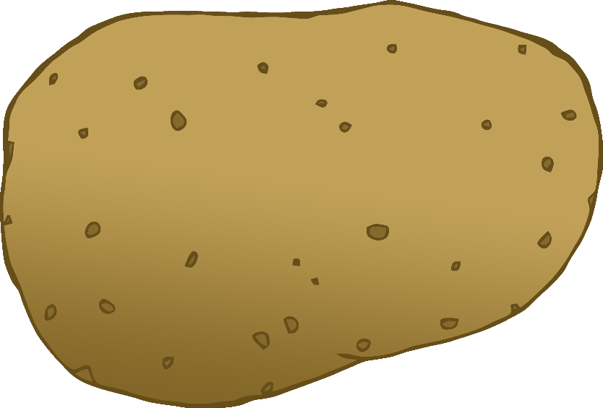

English/Portuguese

© 2020 Little Owls Resources

tomato

tomate

(toh-mar-chi)

English/Portuguese

© 2020 Little Owls Resources

potato

batata

(ba-ta-ta)

carrot

cenoura

(sen-ora)

English/Portuguese

© 2020 Little Owls Resources

lettuce

alface

(al-fah-si)

English/Portuguese

© 2020 Little Owls Resources

cucumber

pepino

(pep-ee-no)

English/Portuguese

© 2020 Little Owls Resources

apple

maçã

(mass-uh)

English/Portuguese

English/Portuguese

English/Portuguese

English/Portuguese

English/Portuguese

English/Portuguese

English/Portuguese

English/Portuguese

© 2020 Little Owls Resources

orange

laranja

(laran-jzuh)

English/Portuguese

© 2020 Little Owls Resources

banana

banana

(ba-na-na)

English/Portuguese

© 2020 Little Owls Resources

strawberry

morango

(mo-ren-go)

English/Portuguese

© 2020 Little Owls Resources

peach

pêssego

(pess-eh-go)

English/Portuguese

© 2020 Little Owls Resources