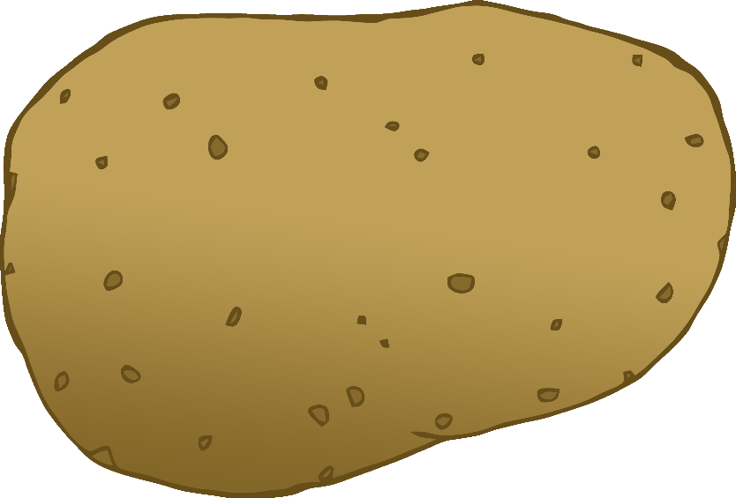

English/Polish

© 2020 Little Owls Resources

tomato

pomidor

(pom-ee-dor)

English/Polish

© 2020 Little Owls Resources

potato

ziemniak

(jzem-nyak)

carrot

marchewka

(mar-heff-kah)

English/Polish

© 2020 Little Owls Resources

lettuce

sałata

(sa-wa-ta)

English/Polish

© 2020 Little Owls Resources

cucumber

ogórek

(og-oo-rek)

English/Polish

© 2020 Little Owls Resources

apple

jabłko

(yab-oo-k-o)

English/Polish

© 2020 Little Owls Resources

orange

pomarańcza

(pom-or-an-cha)

English/Polish

© 2020 Little Owls Resources

banana

banan

(ba-nan)

English/Polish

© 2020 Little Owls Resources

strawberry

truskawki

(trooss-kaff-kee)

English/Polish

© 2020 Little Owls Resources

peach

brzoskwinia

(brj-osk-vin-ya)

English/Polish

© 2020 Little Owls Resources