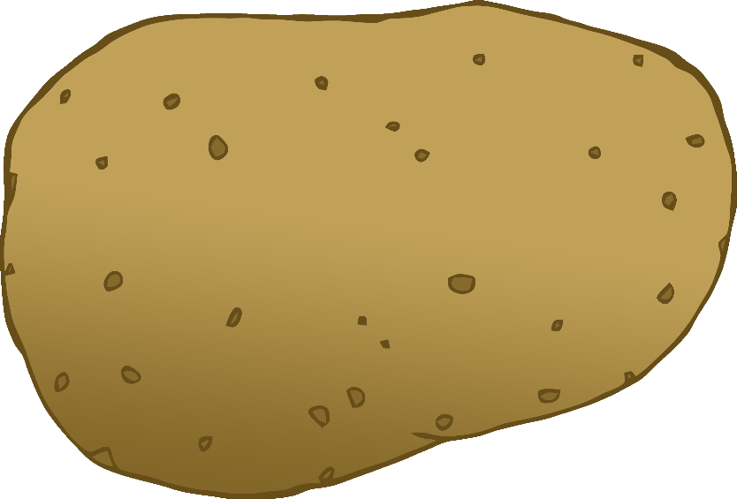

English/Japanese

© 2020 Little Owls Resources

tomato

トマト

(tom-ar-toh)

English/Japanese

© 2020 Little Owls Resources

potato

じゃがいも

(jag-eye-moh)

carrot

にんじん

(nin-jin)

English/Japanese

© 2020 Little Owls Resources

lettuce

レタス

(reta-soo)

English/Japanese

© 2020 Little Owls Resources

cucumber

きゅうり

(k-yoor-ee)

English/Japanese

© 2020 Little Owls Resources

apple

りんご

(ring-o)

English/Japanese

© 2020 Little Owls Resources

orange

オレンジ

(o-ren-jee)

English/Japanese

© 2020 Little Owls Resources

banana

バナナ

(ba-na-na)

English/Japanese

© 2020 Little Owls Resources

strawberry

いちご

(itch-eeg-o)

English/Japanese

© 2020 Little Owls Resources

peach

もも

(mo-mo)

English/Japanese

© 2020 Little Owls Resources