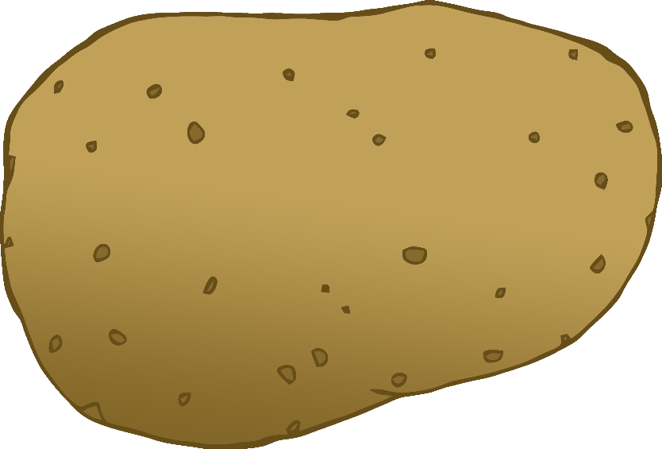

English/Italian

© 2020 Little Owls Resources

tomato

pomodoro

(pom-oh-dor-oh)

English/Italian

© 2020 Little Owls Resources

potato

patata

(pa-ta-ta)

carrot

carota

(ca-rot-a)

English/Italian

© 2020 Little Owls Resources

lettuce

lattuga

(lat-oo-ga)

English/Italian

© 2020 Little Owls Resources

cucumber

cetriolo

(chet-ree-oh-loh)

English/Italian

© 2020 Little Owls Resources

apple

mela

(meh-la)

English/Italian

© 2020 Little Owls Resources

orange

arancia

(a-ran-cha)

English/Italian

© 2020 Little Owls Resources

banana

banana

(ba-na-na)

English/Italian

© 2020 Little Owls Resources

strawberry

fragola

(fra-go-la)

English/Italian

© 2020 Little Owls Resources

peach

pesca

(pess-ka)

English/Italian

© 2020 Little Owls Resources