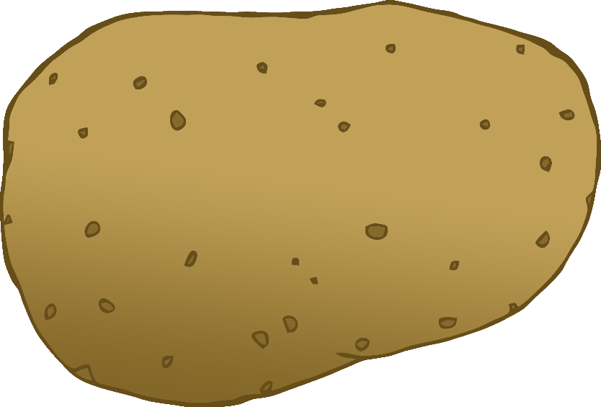

English/German

© 2020 Little Owls Resources

tomato

Tomate

(tom-ar-tuh)

English/German

© 2020 Little Owls Resources

potato

Kartoffel

(kar-toff-l)

carrot

Möhre

(m-ur-uh)

English/German

© 2020 Little Owls Resources

lettuce

Kopfsalat

(kopf-sa-lat)

English/German

© 2020 Little Owls Resources

cucumber

Salatgurke

(za-lat-gur-kuh)

English/German

© 2020 Little Owls Resources

apple

Apfel

(up-fel)

English/German

/Portuguese

English/Portuguese

English/Portuguese

English/Portuguese

English/Portuguese

English/Portuguese

English/Portuguese

English/Portuguese

© 2020 Little Owls Resources

orange

Orange

(or-un-jzer)

English/German

© 2020 Little Owls Resources

banana

Banane

(ba-nar-ner)

English/German

© 2020 Little Owls Resources

strawberry

Erdbeere

(urd-beer-uh)

English/German

© 2020 Little Owls Resources

peach

Pfirsich

(pf-ur-zikh)

English/German

© 2020 Little Owls Resources