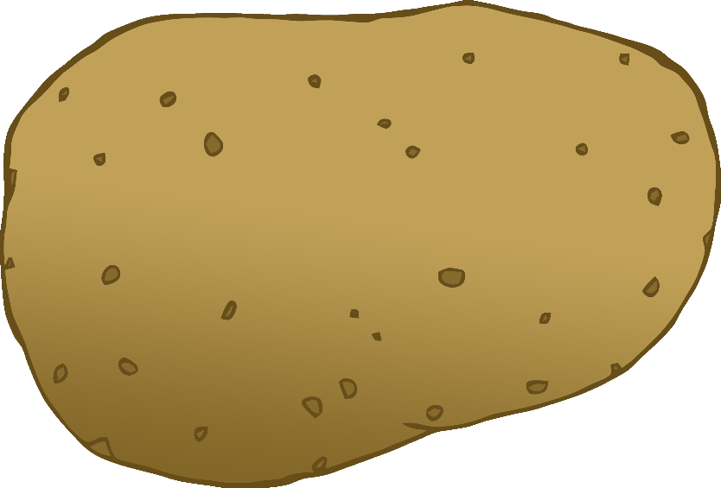

English/French

© 2020 Little Owls Resources

tomato

tomate

(tom-at)

English/French

© 2020 Little Owls Resources

potato

pomme de terre

(pom-d-tair)

carrot

carotte

(cah-rot)

English/French

© 2020 Little Owls Resources

lettuce

laitue

(let-yoo)

English/French

© 2020 Little Owls Resources

cucumber

concombre

(con-com-brr)

English/French

© 2020 Little Owls Resources

apple

pomme

(pom)

English/French

/Portuguese

English/Portuguese

English/Portuguese

English/Portuguese

English/Portuguese

English/Portuguese

English/Portuguese

English/Portuguese

© 2020 Little Owls Resources

orange

orange

(o-ron-j)

English/French

© 2020 Little Owls Resources

banana

banane

(ban-an)

English/French

© 2020 Little Owls Resources

strawberry

fraise

(frez)

English/French

© 2020 Little Owls Resources

peach

pêche

(pesh)

English/French

© 2020 Little Owls Resources