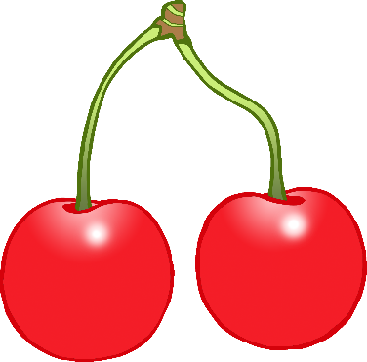

**Fruit and**

**Vegetable Diary**

© 2020 Little Owls Resources

© 2020 Little Owls Resources

On **Monday** what fruits or vegetables did you eat?

© 2020 Little Owls Resources

On **Tuesday** what fruits or vegetables did you eat?

© 2020 Little Owls Resources

On **Wednesday** what fruits or vegetables did you eat?

© 2020 Little Owls Resources

On **Thursday** what fruits or vegetables did you eat?

© 2020 Little Owls Resources

On **Friday** what fruits or vegetables did you eat?

© 2020 Little Owls Resources

On **Saturday** what fruits or vegetables did you eat?

© 2020 Little Owls Resources

On **Sunday** what fruits or vegetables did you eat?