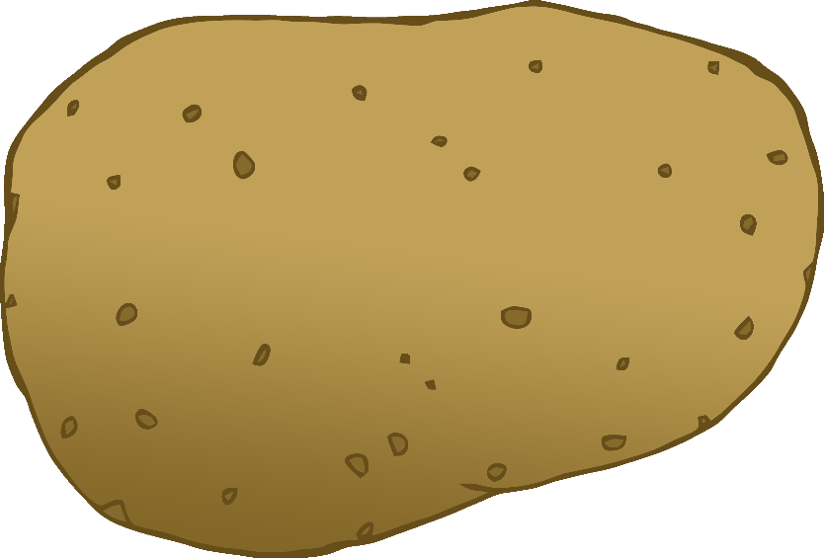

English/Chinese-Mandarin

© 2020 Little Owls Resources

tomato

西红柿

(see-hong-shur)

English/Chinese-Mandarin

© 2020 Little Owls Resources

potato

土豆

(too-doh)

carrot

胡萝卜

(hoo-low-bow)

English/Chinese-Mandarin

© 2020 Little Owls Resources

lettuce

莴苣

(w-oh-joo)

English/Chinese-Mandarin

© 2020 Little Owls Resources

cucumber

黄瓜

(h-wung-bwuh)

English/Chinese-Mandarin

© 2020 Little Owls Resources

apple

苹果

(ping-gor)

English/Chinese-Mandarin

/Portuguese

English/Portuguese

English/Portuguese

English/Portuguese

English/Portuguese

English/Portuguese

English/Portuguese

English/Portuguese

© 2020 Little Owls Resources

orange

橙子

(chung-zur)

English/Chinese-Mandarin

© 2020 Little Owls Resources

banana

香蕉

(sh-yung-jzou)

English/Chinese-Mandarin

© 2020 Little Owls Resources

strawberry

草莓

(t-ou-may)

English/Chinese-Mandarin

© 2020 Little Owls Resources

peach

桃子

(t-ou-zur)

English/Chinese-Mandarin

© 2020 Little Owls Resources