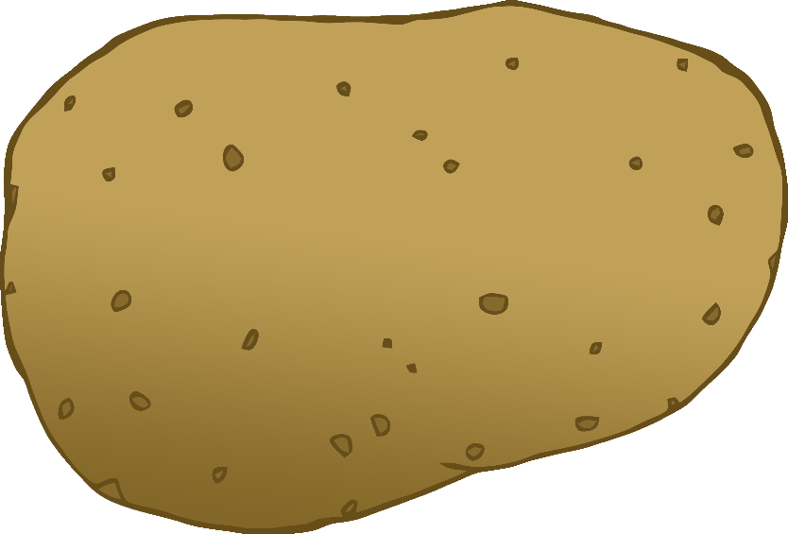

English/Bengali

© 2020 Little Owls Resources

tomato

টমেটো

(tom-eh-toh)

English/Bengali

© 2020 Little Owls Resources

potato

আলু

(ah-loo)

carrot

গাজর

(gar-joor)

English/Bengali

© 2020 Little Owls Resources

lettuce

লেটুস

(let-oosh)

English/Bengali

© 2020 Little Owls Resources

cucumber

শসা

(sosh-ah)

English/Bengali

© 2020 Little Owls Resources

apple

আপেল

(ap-ell)

English/Bengali

© 2020 Little Owls Resources

orange

কমলা

(kom-oh-la)

English/Bengali

© 2020 Little Owls Resources

banana

কলা

(koh-la)

English/Bengali

© 2020 Little Owls Resources

strawberry

স্ট্রবেরি

(str-or-beh-ree)

English/Bengali

© 2020 Little Owls Resources

peach

পীচ

(pee-ch)

English/Bengali

© 2020 Little Owls Resources