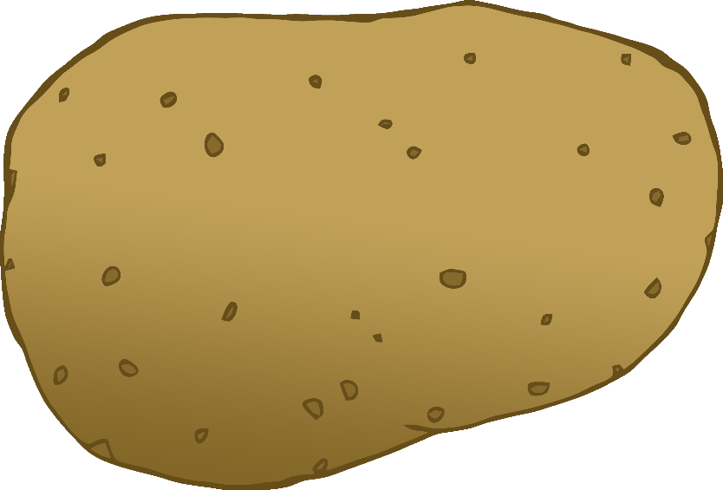

English/Arabic

© 2020 Little Owls Resources

tomato

طماطم

(tah-mar-tim)

English/Arabic

© 2020 Little Owls Resources

potato

بطاطس

(ba-tar-tiss)

carrot

جزر

(juzz-arr)

English/Arabic

© 2020 Little Owls Resources

lettuce

خس

(hh-uss)

English/Arabic

© 2020 Little Owls Resources

cucumber

خيار

(hh-ee-ar)

English/Arabic

© 2020 Little Owls Resources

apple

تفاحة

(too-far-ha)

English/Arabic

/Portuguese

English/Portuguese

English/Portuguese

English/Portuguese

English/Portuguese

English/Portuguese

English/Portuguese

English/Portuguese

© 2020 Little Owls Resources

orange

برتقال

(burt-oo-cull)

English/Arabic

© 2020 Little Owls Resources

banana

موز

(mouzz)

English/Arabic

© 2020 Little Owls Resources

strawberry

فَراوْلة

(fu-rah-wil-a)

English/Arabic

© 2020 Little Owls Resources

peach

خوخ

(kh-ou-hh)

English/Arabic

© 2020 Little Owls Resources