Fruit

Slushies

Activity

Science

p2: Activity Card (detailed breakdown of the activity, vocabulary, questions, etc.)

p3: ‘Family Fun’ Activity Cards (shorthand version of the activity to send home)

p4: ‘Fruit Slushies’ poster (for use with our Science ‘Activity Space’ Banners)

p5: Colour mat

p6: Colour mixing sheet

p7-9: Melt, Freeze, Solid-Liquid-Gas posters

p10: ‘Fruit Slushies’ poster

p11: ‘Ice cubes in cup’ colouring page

p12-16: Word cards (for display or as flash cards)

p17-19: ‘What did we do?’ sheets (for writing, drawing, or adding a photograph)

p20-22: ‘What did we find out?’ sheets (for writing, drawing, or adding a photograph)

This pack includes…

© 2022 Little Owls Resources

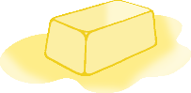

Slushies

Fruit

Science

Activity

What colours can you see? What are the ice cubes like? What has happened to the ice cubes? What has changed? What has stayed the same? What do you think/predict will happen to the ice cubes? What makes you think that? Can we make the ice cubes melt faster? Once the ice has melted, can we get back the ice cubes? What would be the same/different? What effect does temperature have?

2 or more fruit juices or squashes, ice cube tray,

drinking vessel(s) to place ice cubes in (ideally tall clear plastic cups)

Optional – food colouring

(Understanding the World)

Extra Challenge!

Start by freezing some different coloured fruit juices or squashes into ice cubes. (For more exciting or bolder colours you might like to add food colouring.) Once frozen, place the ice cubes into a clear container; ideally a tall plastic cup so that children can see what happens as the coloured ice cubes melt and are able to handle it themselves.

With younger children you might like to concentrate on their hands on experience of the ice and how it changes as it melts, using words such as ‘cold’, ‘ice’ and ‘melting’. This investigation is also a fantastic opportunity to look at colour. Notice how the colours drip and mix into one another. Can they make the ice melt faster? *(E.g. holding their warm hands around the outside of the cup, using a spoon to stir the ice or chip away at it.)*

As the children get older there is more scope for describing the qualities of the two states of matter (‘solid’ and ‘liquid’) and the **process of change** from one to the other; first **freezing** the fruit juices and then allowing them to ‘**melt**’.

For additional depth to the investigation, set up an experiment and place 2 or 3 slushies in different places, e.g. one in the fridge and another out on the table. Which one melts the quickest/slowest? Or experiment with the different colours you can make.

Discuss – Once the ice has melted, can we reverse the process to get back the ice cubes? If we tried this, what would be the same/different? Why not test pouring the liquid back into the ice trays and into the freezer!

Key Questions:

(Progressing in difficulty)

Key Vocabulary:

(Progressing in difficulty)

Further resources within this pack. Plus, ‘Water Play’ resources at

<https://littleowls-premium.com/outdoor-area-water-play>

Additional Resources:

*Cold, ice*

*mix, colours* (plus relevant colours used),

*hard, solid, freeze, frozen,*

*runny, drip, melt, liquid,*

*change, temperature*

**Birth to 3** – Explore materials with ***different properties***. – Explore and respond to different natural phenomena in their setting and on trips.

**3 and 4 –** Talk about what they see, using a wide vocabulary. – Explore how things work. – Talk about the differences between materials and ***changes they notice***.

**Reception –** Explore the natural world around them. **ELG:** Understand some important processes and changes in the natural world around them, including the seasons and ***changing states of matter***.

Development Matters:

© 2022 Little Owls Resources

Activity Description:

You will need:

ttt

Family Fun!

Start by freezing some different coloured fruit juices or squashes into ice cubes.

Once frozen, place the ice cubes into a clear container, perhaps a plastic cup so that you can see what happens to the coloured ice cubes as time passes.

Describe what you find out using words such as ‘cold’, ‘ice’ and ‘melting’. Also, use the colour names and look what happens to them as they drip and mix into one another.

We’d love to see some photos or drawings of your slushy experiments!

© 2022 Little Owls Resources

Slushies

Fruit

ttt

Family Fun!

Start by freezing some different coloured fruit juices or squashes into ice cubes.

Once frozen, place the ice cubes into a clear container, perhaps a plastic cup so that you can see what happens to the coloured ice cubes as time passes.

Describe what you find out using words such as ‘cold’, ‘ice’ and ‘melting’. Also, use the colour names and look what happens to them as they drip and mix into one another.

We’d love to see some photos or drawings of your slushy experiments!

© 2022 Little Owls Resources

Slushies

Fruit

ttt

Family Fun!

Start by freezing some different coloured fruit juices or squashes into ice cubes.

Once frozen, place the ice cubes into a clear container, perhaps a plastic cup so that you can see what happens to the coloured ice cubes as time passes.

Describe what you find out using words such as ‘cold’, ‘ice’ and ‘melting’. Also, use the colour names and look what happens to them as they drip and mix into one another.

We’d love to see some photos or drawings of your slushy experiments!

© 2022 Little Owls Resources

Slushies

Fruit

ttt

Family Fun!

Start by freezing some different coloured fruit juices or squashes into ice cubes.

Once frozen, place the ice cubes into a clear container, perhaps a plastic cup so that you can see what happens to the coloured ice cubes as time passes.

Describe what you find out using words such as ‘cold’, ‘ice’ and ‘melting’. Also, use the colour names and look what happens to them as they drip and mix into one another.

We’d love to see some photos or drawings of your slushy experiments!

© 2022 Little Owls Resources

Slushies

Fruit

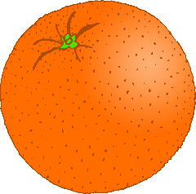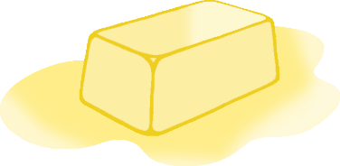

Slushies

Fruit

© 2022 Little Owls Resources

*\*For use with the ‘Science Banner’ display.*

**Colour Mat**

pink

purple

black

orange

white

brown

green

blue

yellow

© 2022 Little Owls Resources

red

Colour Mixing

© 2022 Little Owls Resources

Second Colour

First Colour

Mixture Colour

melt

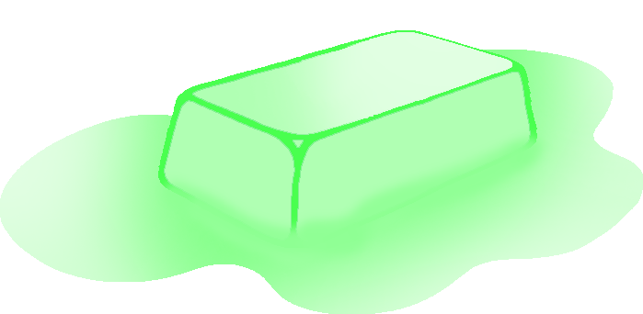

melting

© 2022 Little Owls Resources

freeze

freezing

© 2022 Little Owls Resources

gas

liquid

solid

liquid

solid

gas

© 2022 Little Owls Resources

Slushies

Fruit

Try mixing up the coloured ice cubes.

Try stacking the coloured ice cubes.

© 2022 Little Owls Resources

© 2022 Little Owls Resources

© 2022 Little Owls Resources

ice

colours

cold

mix

hard

solid

© 2022 Little Owls Resources

© 2022 Little Owls Resources

© 2022 Little Owls Resources

freeze

frozen

change

© 2022 Little Owls Resources

© 2022 Little Owls Resources

© 2022 Little Owls Resources

drip

melt

liquid

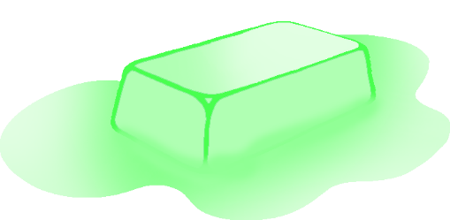

© 2022 Little Owls Resources

© 2022 Little Owls Resources

© 2022 Little Owls Resources

temperature

© 2022 Little Owls Resources

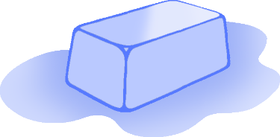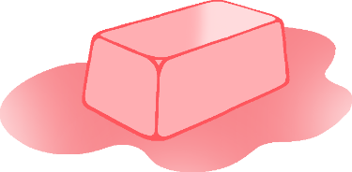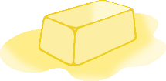

What did we do?

__________________________________________________________________

© 2022 Little Owls Resources



What did we do?

____________________________

© 2022 Little Owls Resources



What did we do?

© 2022 Little Owls Resources

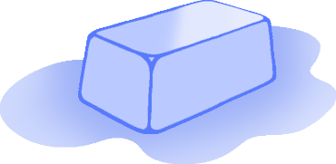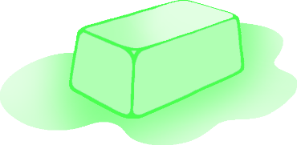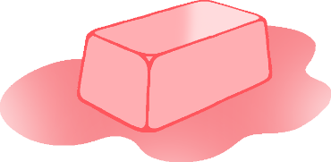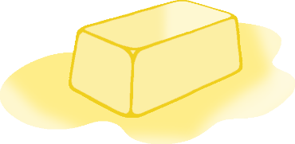

What did we find out?

__________________________________________________________________

© 2022 Little Owls Resources



What did we find out?

____________________________

© 2022 Little Owls Resources



What did we find out?

© 2022 Little Owls Resources