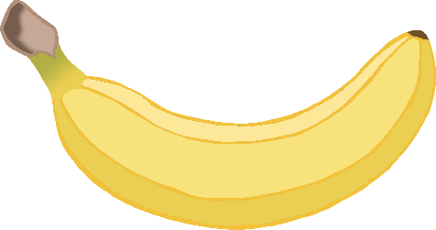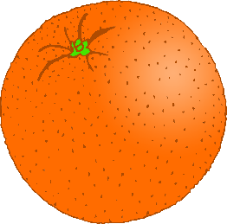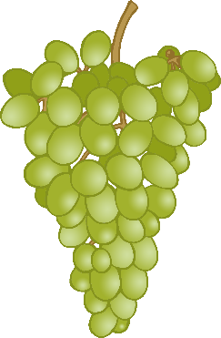

orange

apple

banana

strawberries

grapes

pineapple

raspberries

blueberries

peach

cherries

pear

watermelon

**Fruit**

© 2021 Little Owls Resources

peach

cherries

watermelon

strawberries

orange

apple

grapes

pineapple

raspberries

blueberries

pear

banana

**Fruit**

© 2021 Little Owls Resources