Frog

© 2020 Little Owls Resources

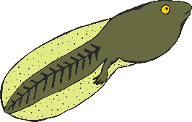

Tadpole

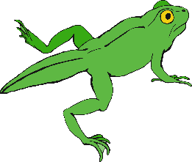

Froglet

**Frog Life Cycle**

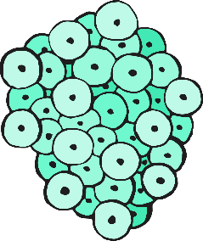

Frogspawn

© 2020 Little Owls Resources

**Frog Life Cycle**



Frogspawn



Tadpole



Froglet

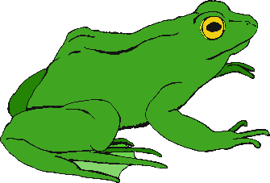

Frog