© 2021 Little Owls Resources

Friendship Fairy!

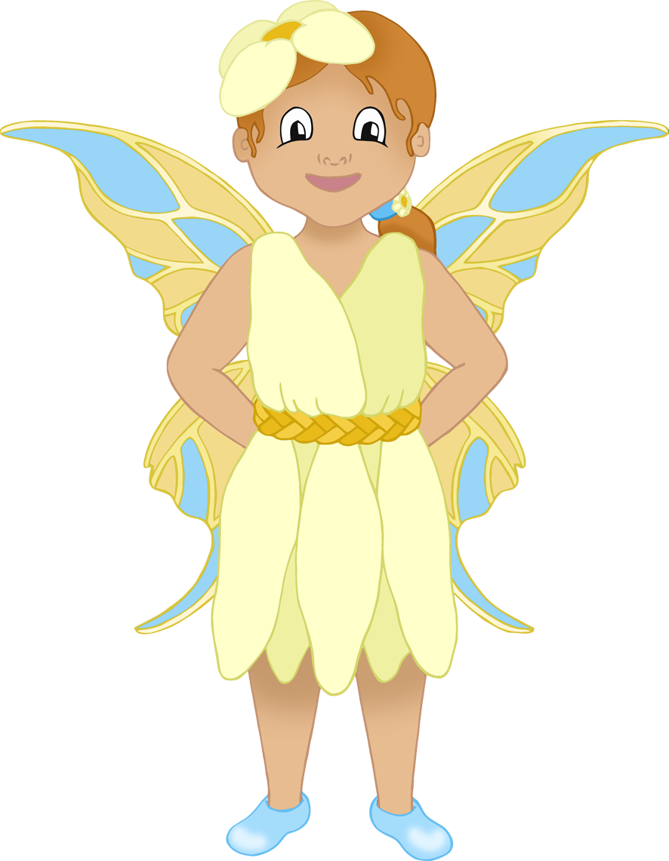

is

MAGIC!

____________________________

________________________________________________________________________________

Friendship Fairy!

© 2021 Little Owls Resources

is

MAGIC!

____________________________

________________________________________________________________________________

Friendship Fairy!

© 2021 Little Owls Resources

is

MAGIC!

____________________________

________________________________________________________________________________

Friendship Fairy!

© 2021 Little Owls Resources

is

MAGIC!

____________________________

________________________________________________________________________________

Friendship Fairy!

© 2021 Little Owls Resources

is

MAGIC!

____________________________

________________________________________________________________________________

Friendship Fairy!

© 2021 Little Owls Resources

is

MAGIC!

____________________________

________________________________________________________________________________

