Greeting Cards Activity – Friendship

The activity is intended to encourage the children to really think about their friend’s likes.

Each of these cards has the same message across the front but is accompanied by a different image. The children must think about which card they think their friend will like best before colouring it for them.

*N.B. The final page has a card with no image for the children to draw their own.*

©2022 Little Owls Resources

Thank you for being my friend!

©2022 Little Owls Resources

Thank you

for being my

friend!

©2022 Little Owls Resources

Thank you for being my friend!

©2022 Little Owls Resources

Thank you for being my friend!

©2022 Little Owls Resources

**Thank you for being my friend!**

©2022 Little Owls Resources

Thank you for being my friend!

©2022 Little Owls Resources

**Thank you for being my friend!**

©2022 Little Owls Resources

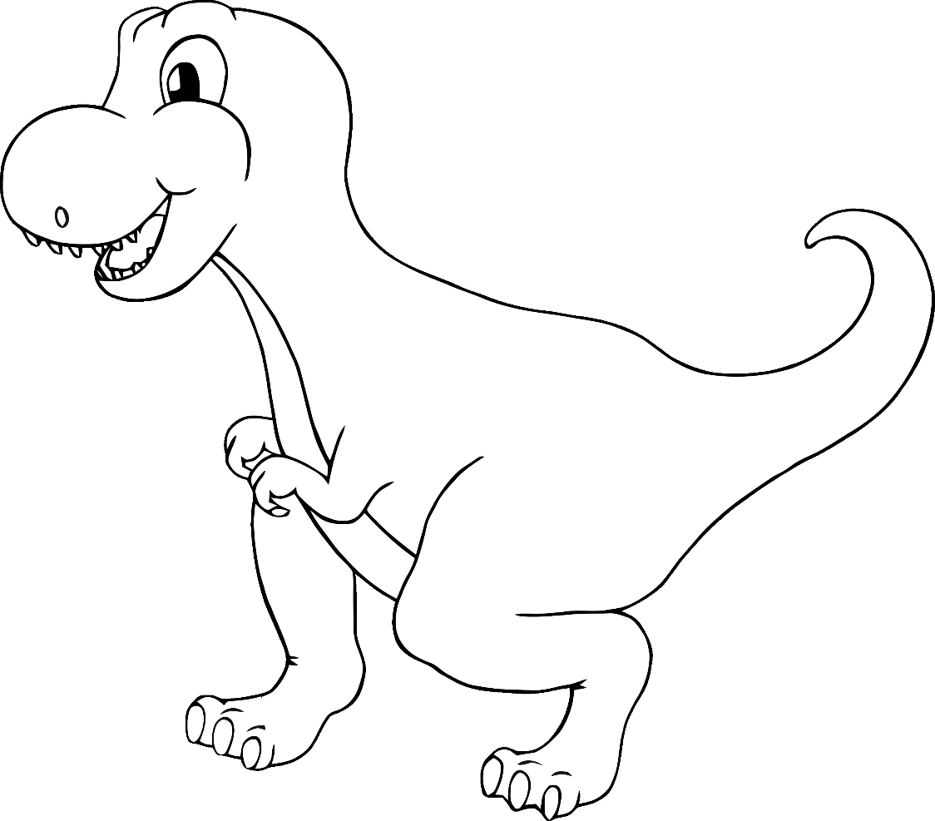

Thank you

for being my friend!

©2022 Little Owls Resources

**Thank you for being my friend!**

©2022 Little Owls Resources

©2022 Little Owls Resources

**Thank you for being my friend!**

©2022 Little Owls Resources

**Thank you for being my friend!**

©2022 Little Owls Resources

**Thank you for being my friend!**

©2022 Little Owls Resources

**Thank you for being my friend!**

©2022 Little Owls Resources

**Thank you for being my friend!**

for being my friend!

Thank you

©2022 Little Owls Resources