Friendship A4 templates

©2022 Little Owls Resources

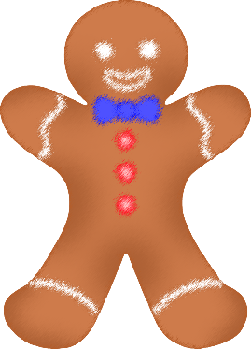

Thank you for being my friend!

Thank you for being my friend!

These templates have detailed outlines to be used as a starting point for an art activity.

The outlines can be coloured, painted, or collaged to create an individual poster design to be given to a loved one.

They could be stuck to a folded piece of A3 card to make a large greeting card!

for josh

Thank you for being my friend!

©2022 Little Owls Resources

Thank you

for being my

friend!

©2022 Little Owls Resources

Thank you for being my friend!

©2022 Little Owls Resources

Thank you

for being my friend!

©2022 Little Owls Resources

**Thank you for being my friend!**

©2022 Little Owls Resources

Thank you for being my friend!

©2022 Little Owls Resources

**Thank you for being my friend!**

©2022 Little Owls Resources

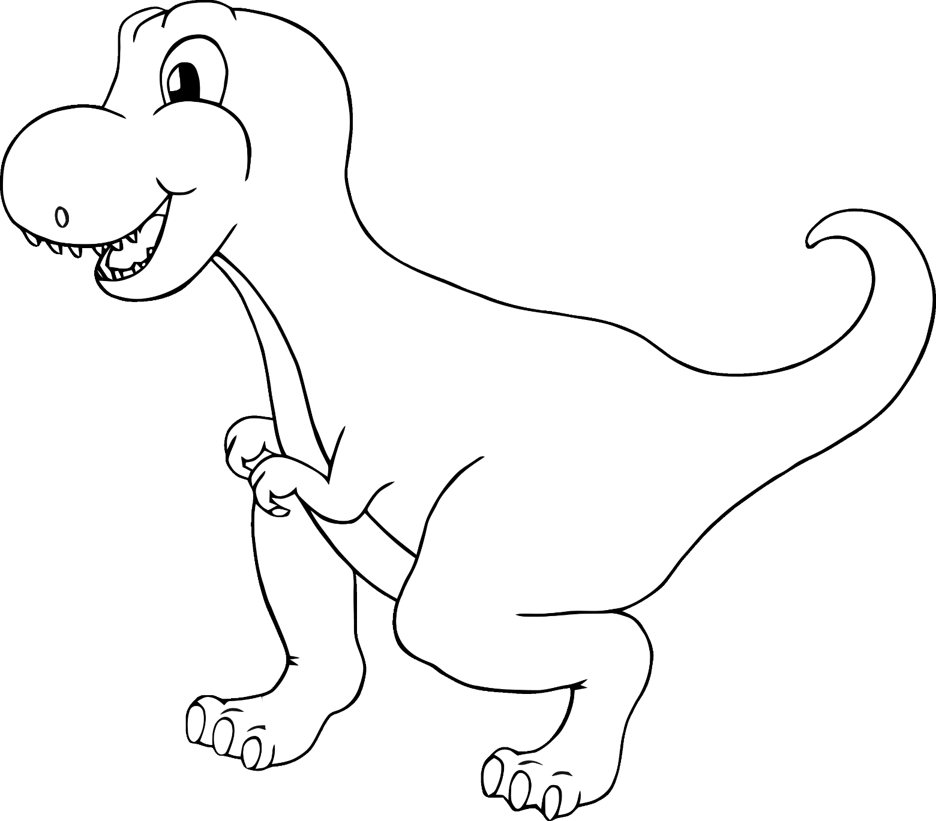

for being my friend!

Thank you

©2022 Little Owls Resources

©2022 Little Owls Resources

**Thank you for being my friend!**

©2022 Little Owls Resources

**Thank you for being my friend!**

**Thank you for being my friend!**

©2022 Little Owls Resources

**Thank you for being my friend!**

©2022 Little Owls Resources

**Thank you for being my friend!**

©2022 Little Owls Resources

**Thank you for being my friend!**

©2022 Little Owls Resources

for being my friend!

Thank you

©2022 Little Owls Resources