**Dinosaurs - Fossil Numbers**

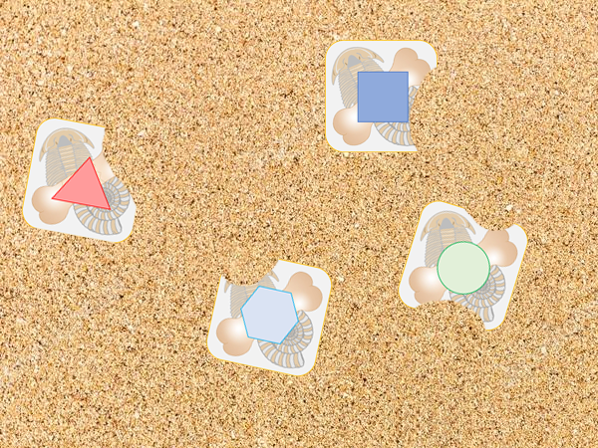

Can you find the fossil shapes buried in the sand?

© 2019 Little Owls Resources

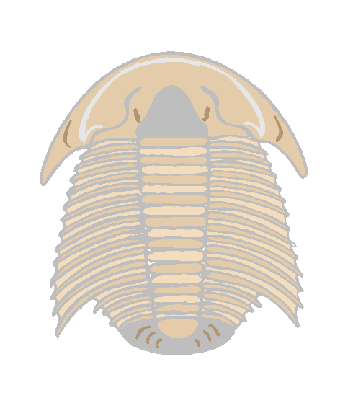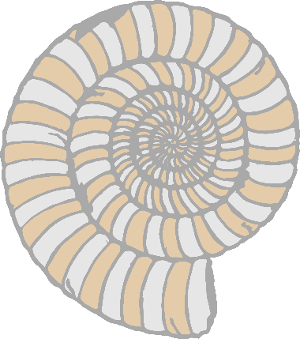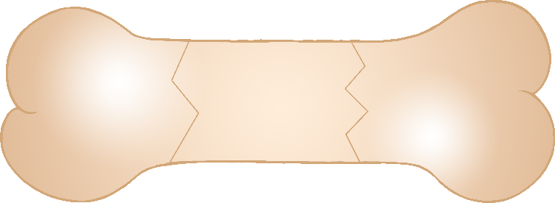

© 2019 Little Owls Resources

© 2019 Little Owls Resources

© 2019 Little Owls Resources

© 2019 Little Owls Resources

© 2019 Little Owls Resources

© 2019 Little Owls Resources



© 2019 Little Owls Resources

© 2019 Little Owls Resources

© 2019 Little Owls Resources

© 2019 Little Owls Resources

© 2019 Little Owls Resources

© 2019 Little Owls Resources



© 2019 Little Owls Resources

© 2019 Little Owls Resources

© 2019 Little Owls Resources

© 2019 Little Owls Resources

© 2019 Little Owls Resources

© 2019 Little Owls Resources

© 2019 Little Owls Resources

© 2019 Little Owls Resources

© 2019 Little Owls Resources

© 2019 Little Owls Resources

© 2019 Little Owls Resources

© 2019 Little Owls Resources

