**Dinosaurs - Fossil Numbers**

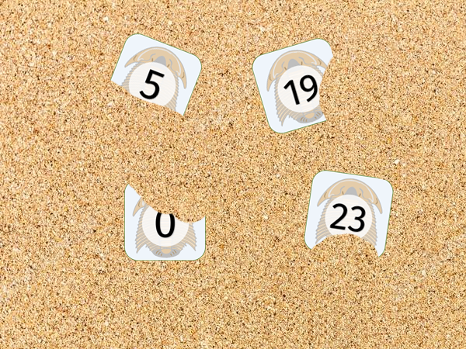

© 2019 Little Owls Resources

Can you find the fossil numbers buried in the sand?

© 2019 Little Owls Resources

© 2019 Little Owls Resources

© 2019 Little Owls Resources

© 2019 Little Owls Resources

© 2019 Little Owls Resources

© 2019 Little Owls Resources

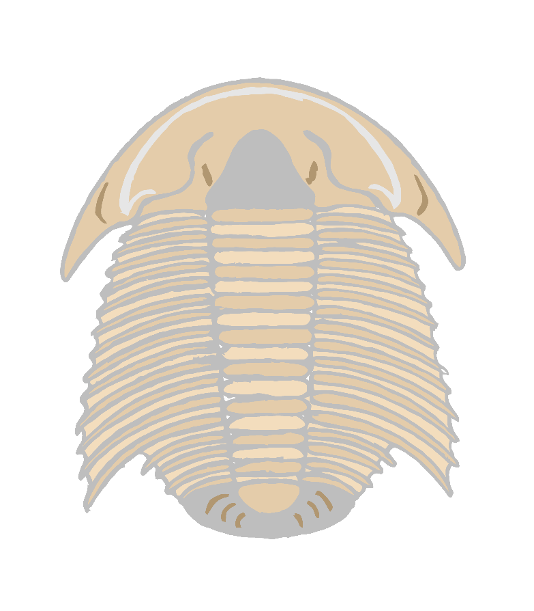

0



3



1



4



2



5



6



9=9



7



10



8



© 2019 Little Owls Resources

© 2019 Little Owls Resources

© 2019 Little Owls Resources

© 2019 Little Owls Resources

© 2019 Little Owls Resources

© 2019 Little Owls Resources

11



© 2019 Little Owls Resources

© 2019 Little Owls Resources

© 2019 Little Owls Resources

© 2019 Little Owls Resources

© 2019 Little Owls Resources

© 2019 Little Owls Resources

17

16

15

14

13

12



© 2019 Little Owls Resources

© 2019 Little Owls Resources

© 2019 Little Owls Resources

© 2019 Little Owls Resources

© 2019 Little Owls Resources

© 2019 Little Owls Resources

23

22

21

20

19

18



29

28

27

26

25

24

© 2019 Little Owls Resources

© 2019 Little Owls Resources

© 2019 Little Owls Resources

© 2019 Little Owls Resources

© 2019 Little Owls Resources

© 2019 Little Owls Resources

© 2019 Little Owls Resources

© 2019 Little Owls Resources

© 2019 Little Owls Resources

© 2019 Little Owls Resources

© 2019 Little Owls Resources

© 2019 Little Owls Resources

-

+

+

=

=

30

