**Dinosaurs - Fossil Numbers**

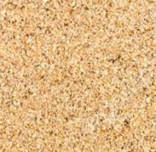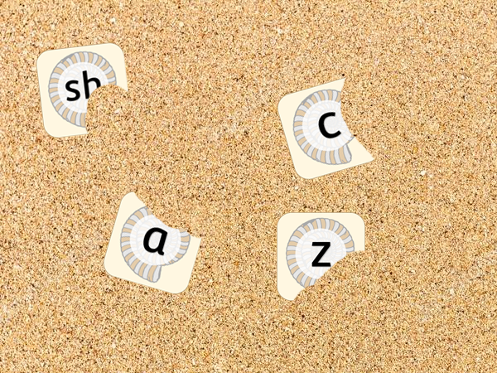

Can you find the fossil letters buried in the sand?

© 2019 Little Owls Resources

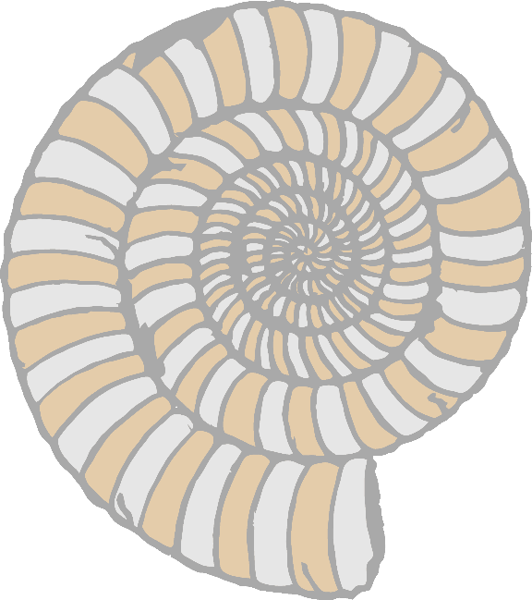

a



d



b



e



c



f



i



hb



g



l



k



j



n



m



o



r



q



p



t



u



**w**



s



v



x



z



y